# Chapter 1: Basic Theory

## 1.1 Shared Responsibility

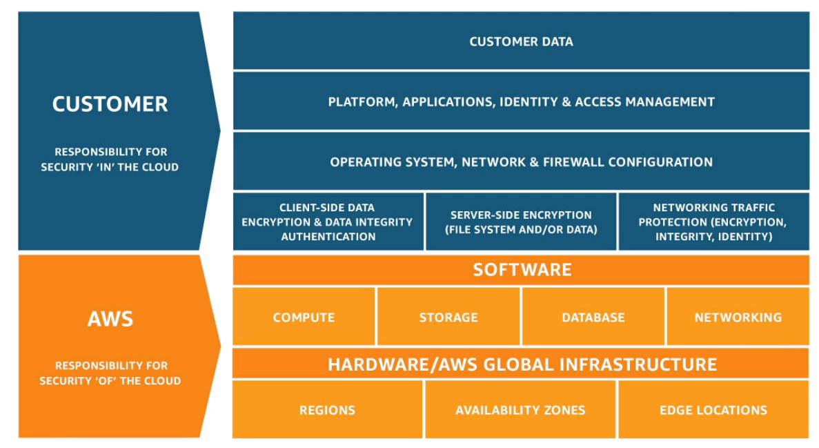

## 1.2 IaaS, PaaS and SaaS

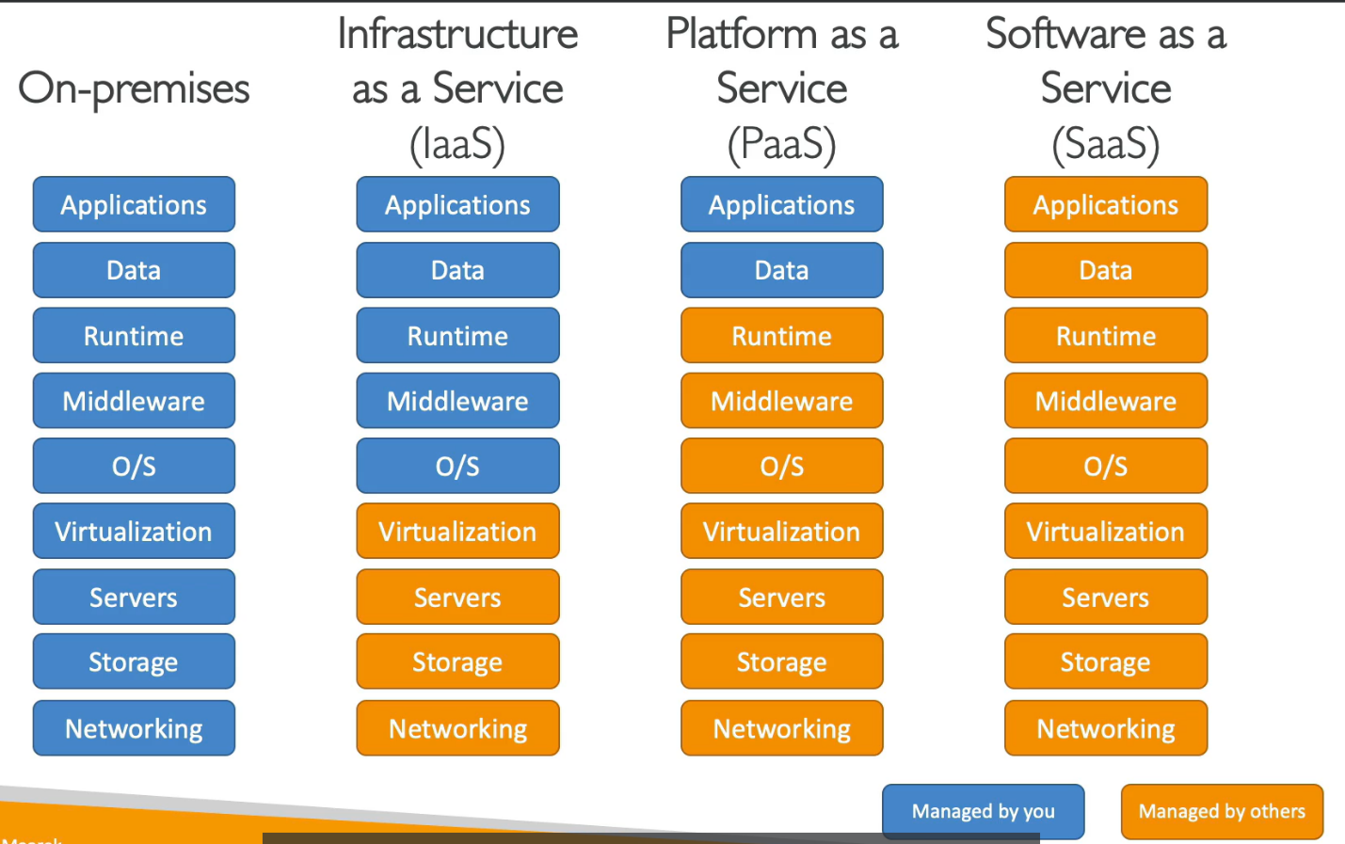

# Chapter 2: IAM

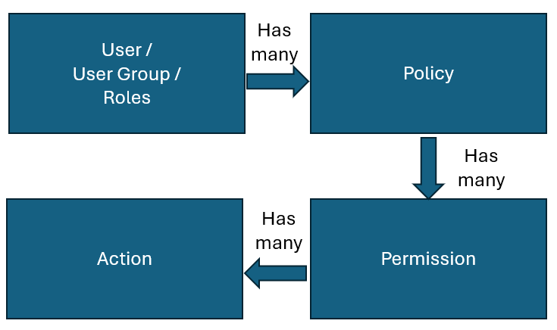

## 2.2 IAM Policy

### 2.2.1 IAM Policy Structure

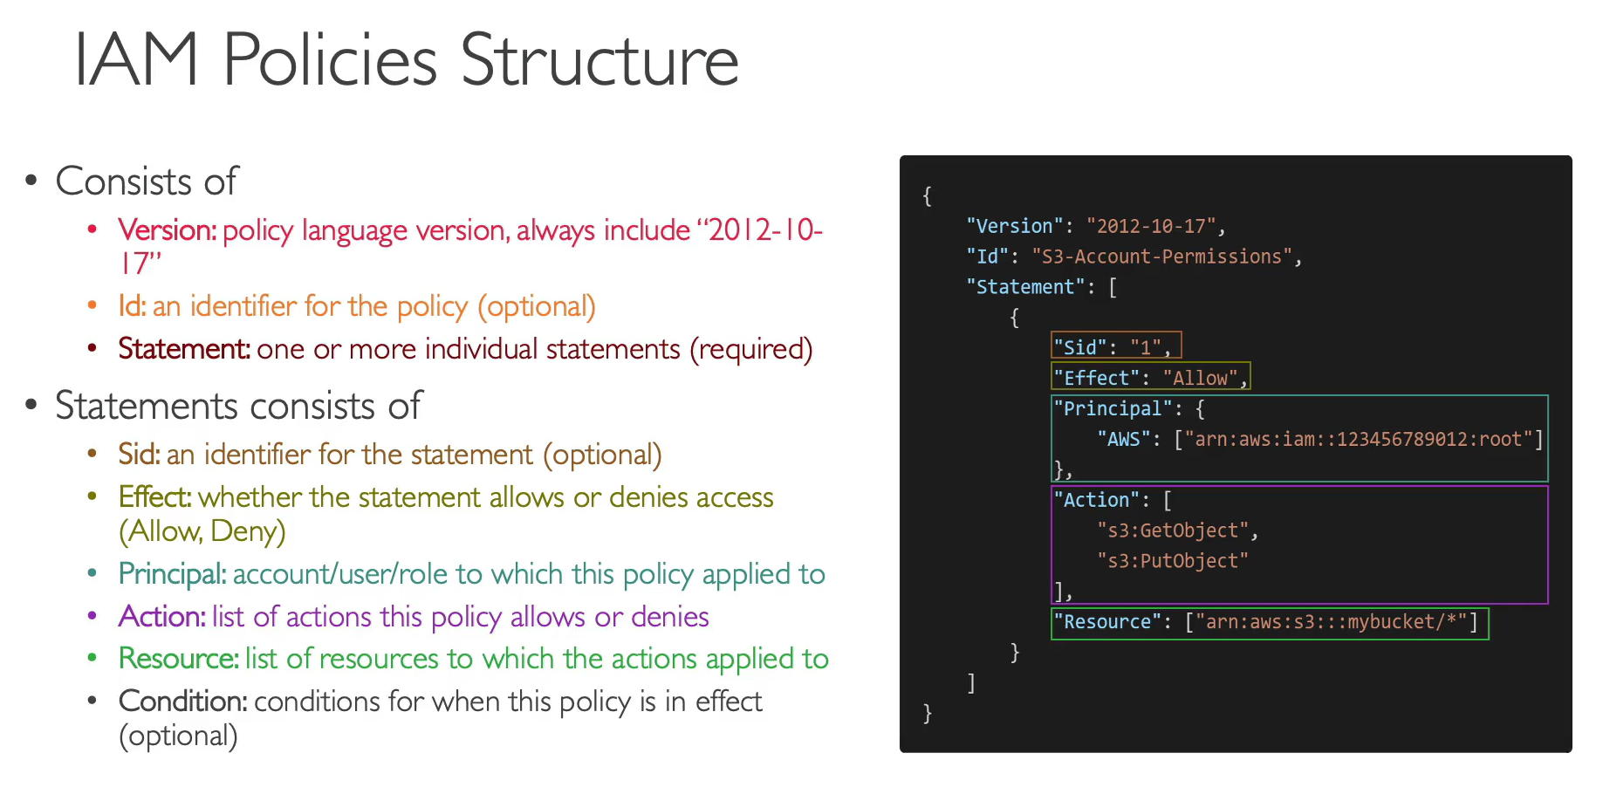

### 2.2.2 IAM Policy List

**Policies = Compact Pre-Set Permission allowed in AWS**

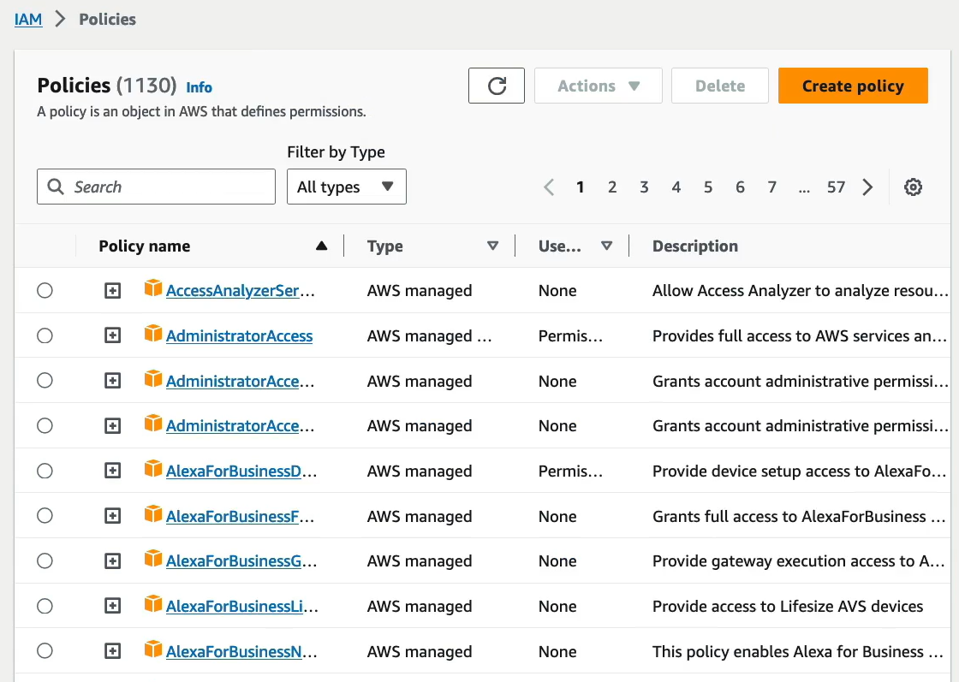

### 2.2.3 IAM Policy (Detailed)

**Eg: AdministratorAccess (Policy)**

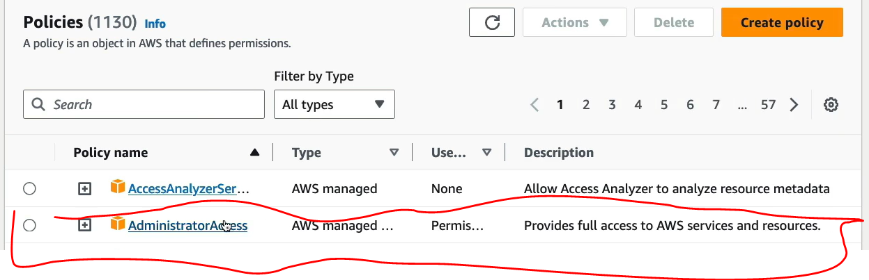

**384 Permissions Allowed**

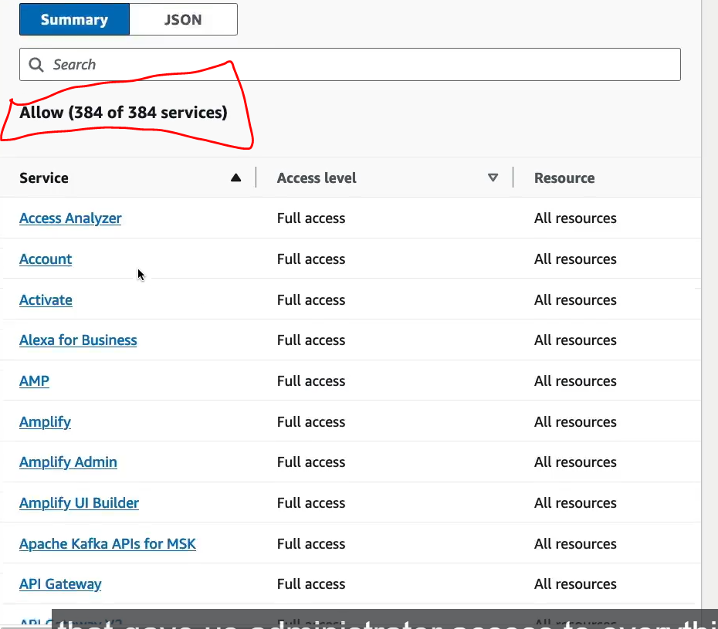

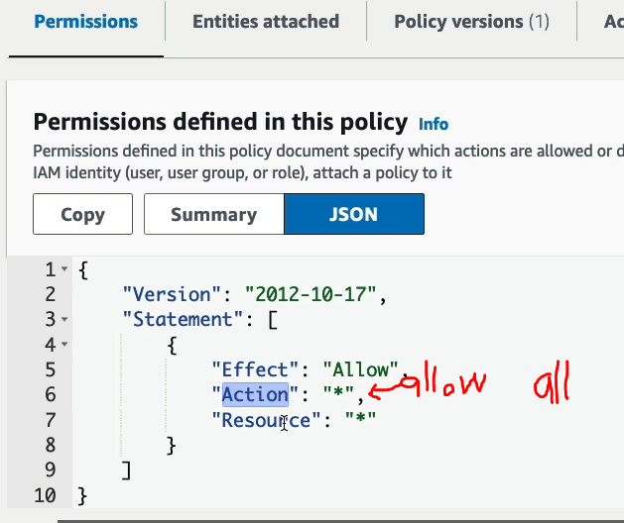

**Eg: IAMReadOnlyAccess (Policy)**

**1 Permission Allowed Only**

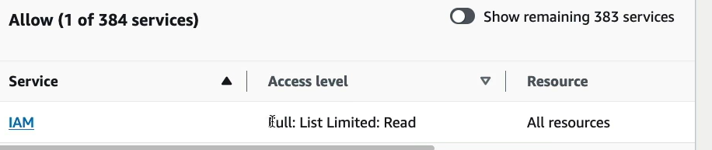

**69 Actions Allowed (IAM Permission)**

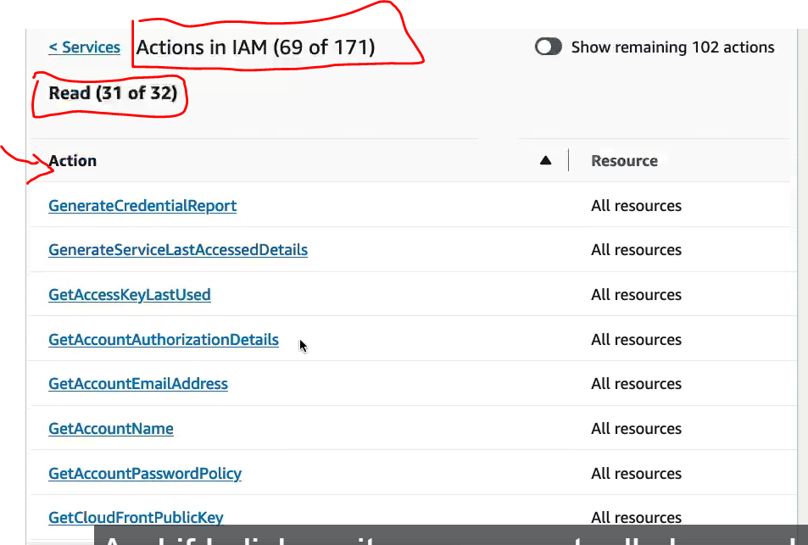

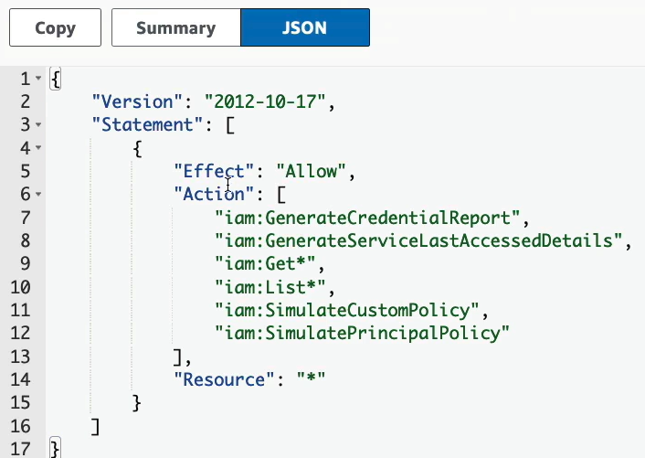

## 2.3 IAM – Permission

### 2.3.2 Choose a way to add permission.

### 2.3.3 Group permission.

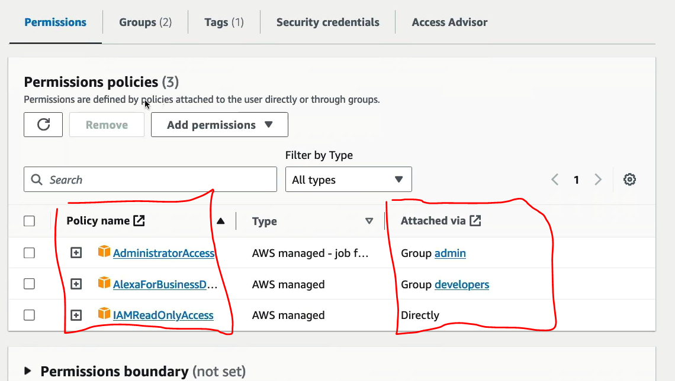

## 2.4 IAM – Password

1. Change Password Regularly

### 2.4.1 - MFA

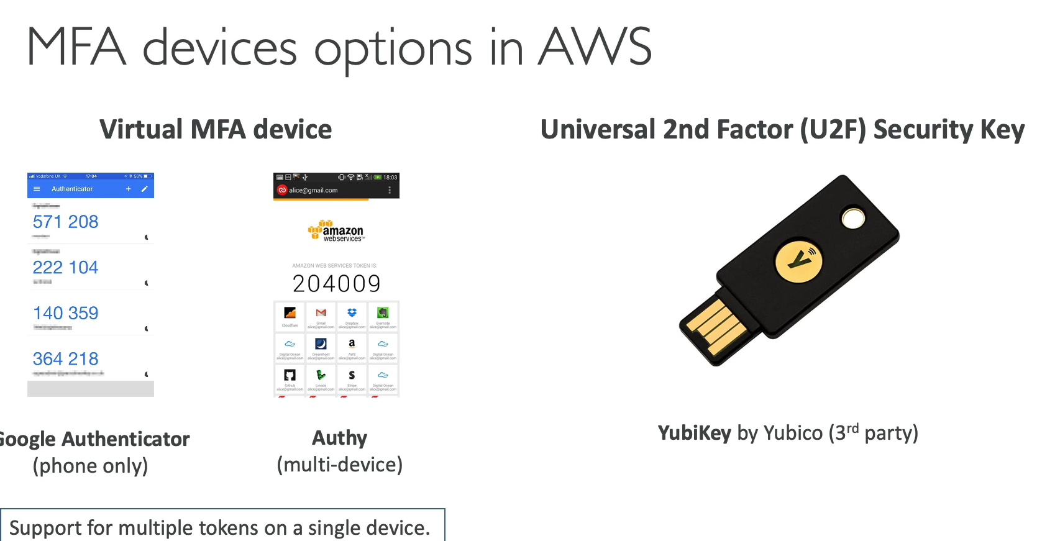

### 2.4.2 – Access Key

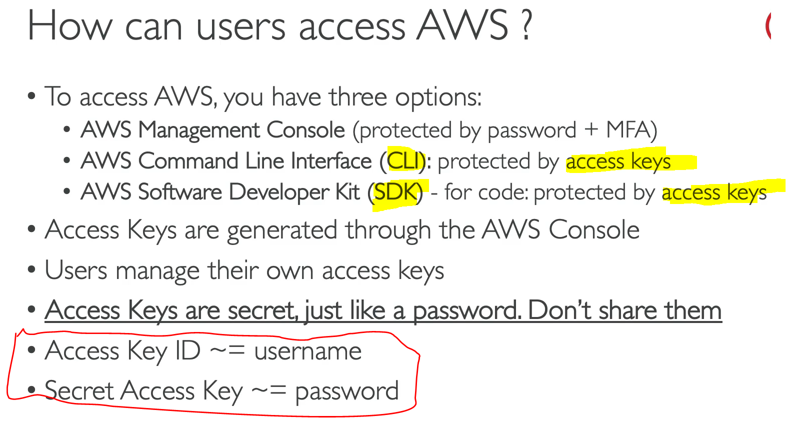

## 2.5 IAM Roles

**Roles = Is only for EC2 instances or AWS Services**

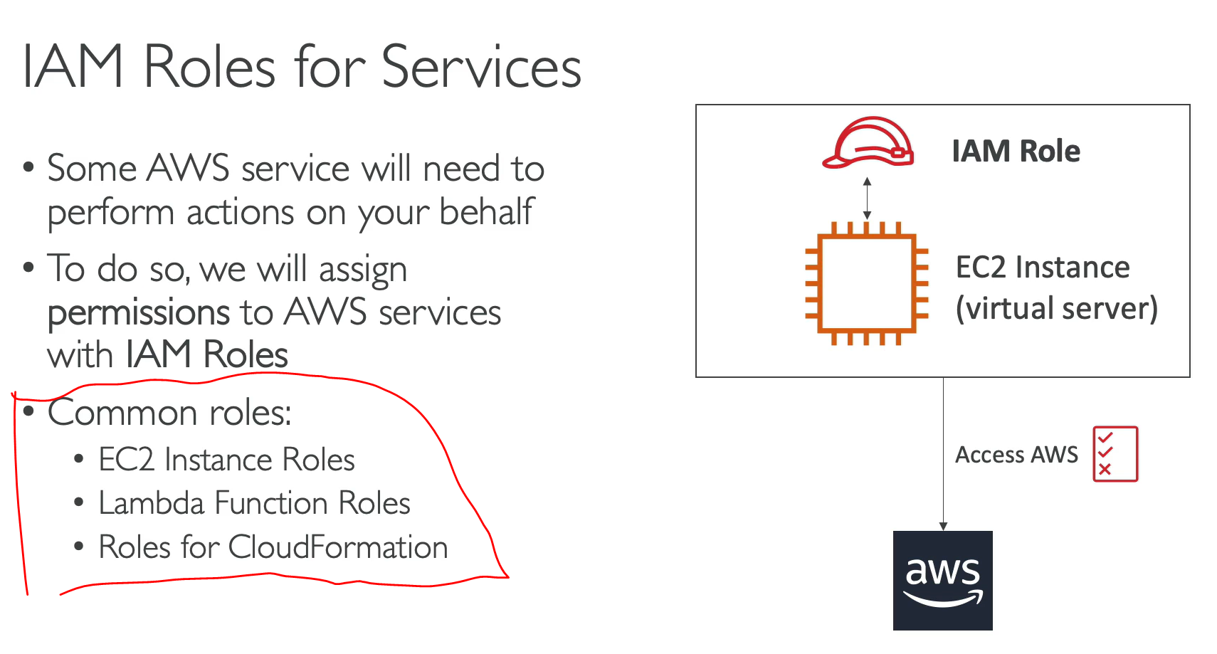

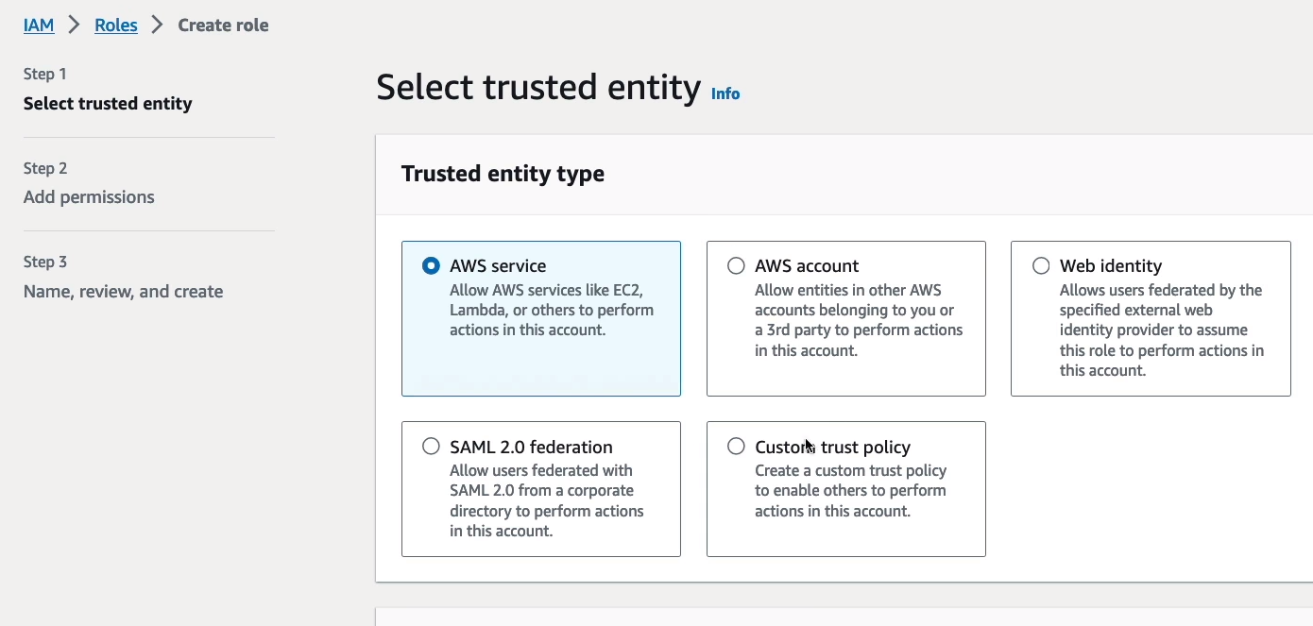

## 2.6 Access Advisor

**Access Advisor = (Monitor User last access to which AWS services)**

* **Can remove access if User never used the Services**
* **Can Stalk people activities xD**

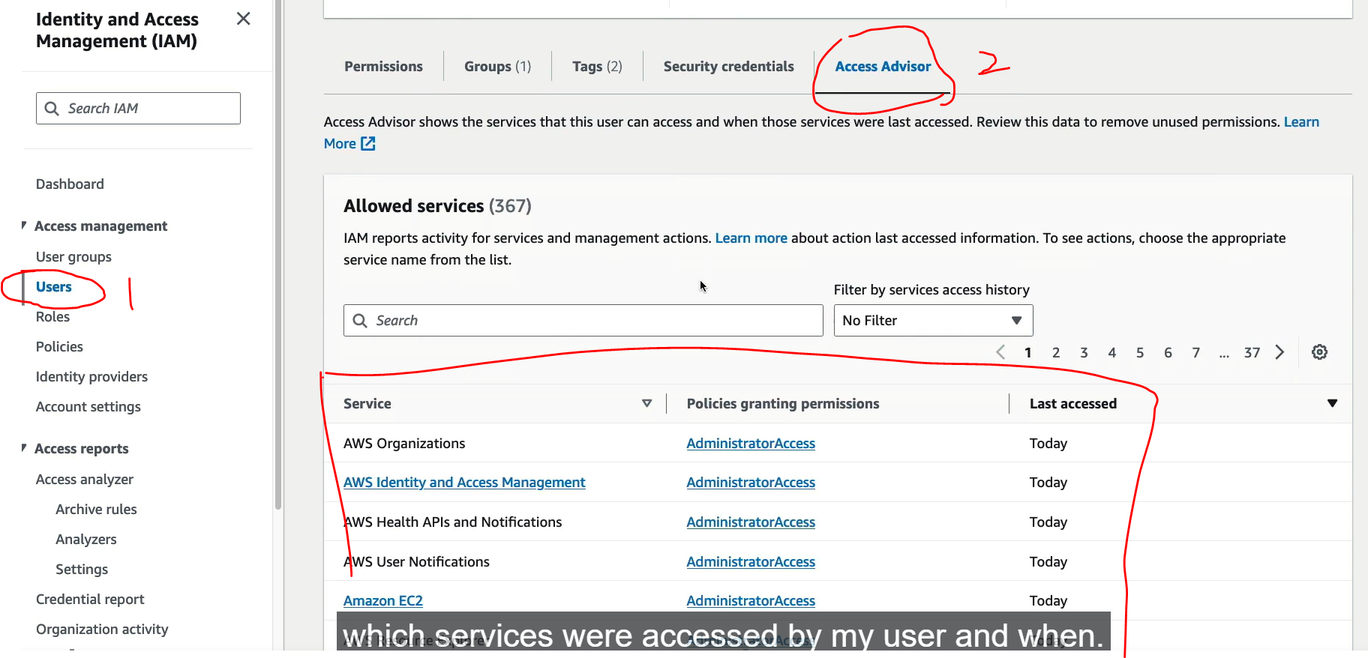

## 2.7 Shared Responsibilities Model for IAM

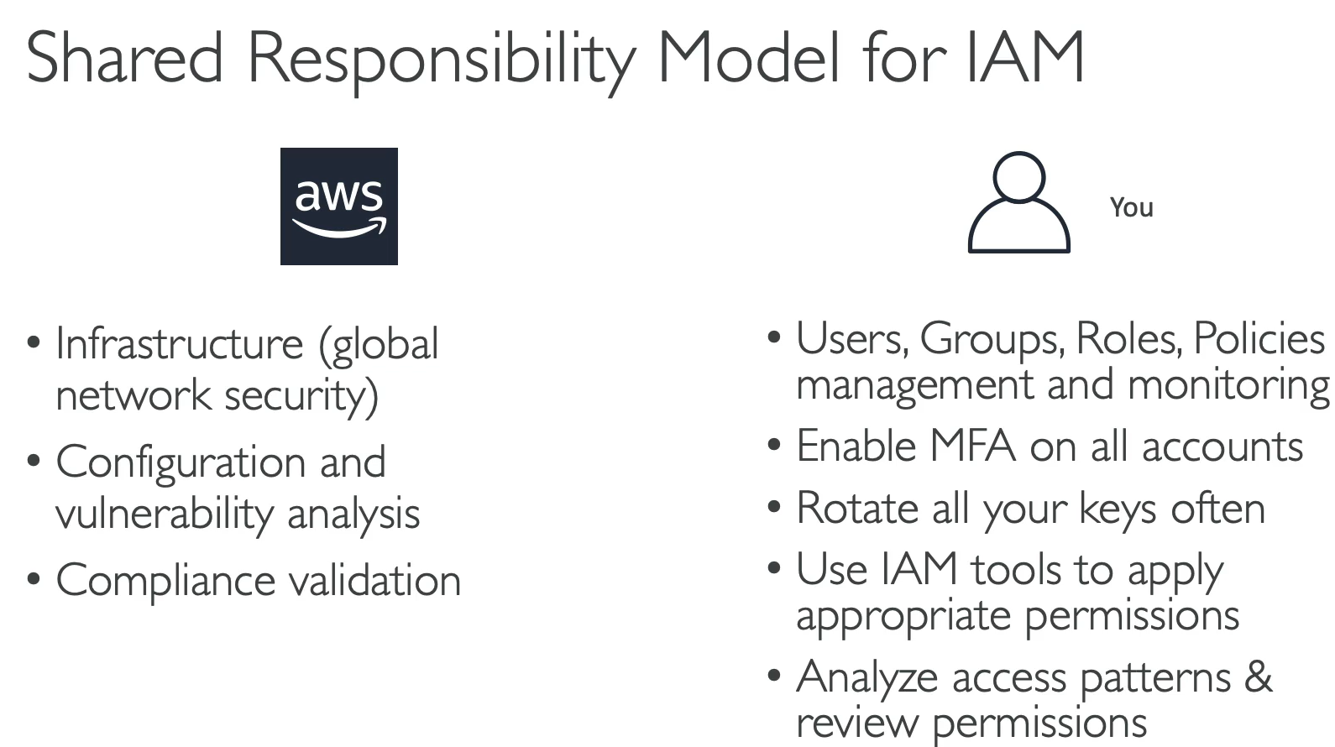

## 2.8 Hard Quiz

# Chapter 3: Elastic Compute Cloud (EC = Compute)

## 3.1 EC Types

### 3.1.1 General Purpose

Good for: (In this course, free tiers plan) / Cheapest – t2

* Web Servers
* Code Repository

Balance between

* Compute
* Memory
* Networking

### 3.1.2 Compute Optimized

Good for High Performance processors – C6 CPU

* Batch Processing workloads.
* Media transcoding
* High performance web servers
* High performance computing (HPC)
* Machine Learning
* Dedicated gaming servers

### 3.1.3 Memory Optimized

Goof for processing large data sets in memory. – R6

* High performance R/non-RDBMS
* Distributed web scale cache stores
* In-memory database optimized for BI (Business Intelligence)
* Applications perform real-time processing of big unstructured data.

### 3.1.4 Accelerated Computing

### 3.1.5 Storage Optimized

Good for storage-intensive task (high speed Read and Write data sets to local storage) – I3

* High frequent online transaction processing (OLTP)
* RDBMS / NoSQL
* Cache in memory (Redis)
* Data warehousing app
* Distributed file systems

### 3.1.6 Instance Features

### 3.1.7 Measuring Instance Performance

## 3.2 Security Group

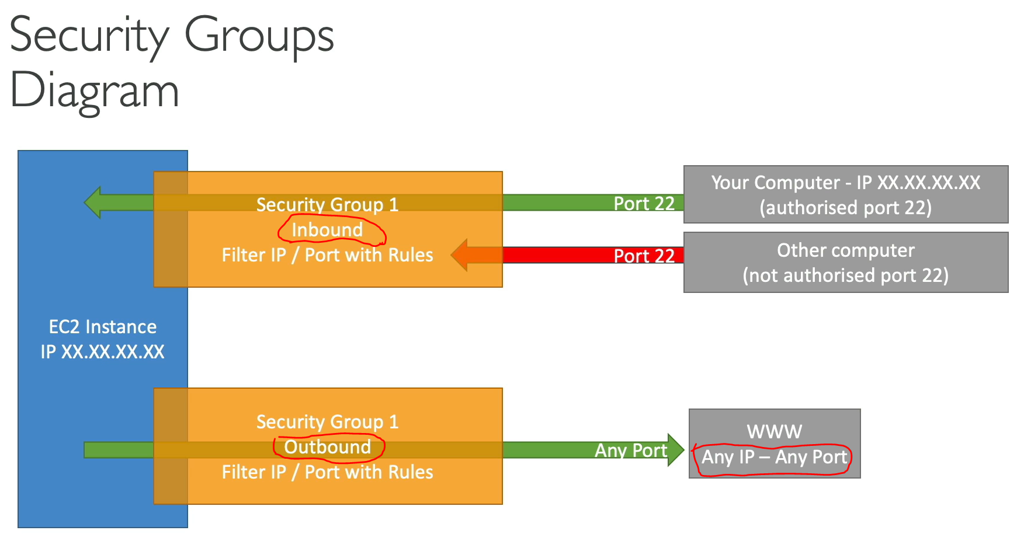

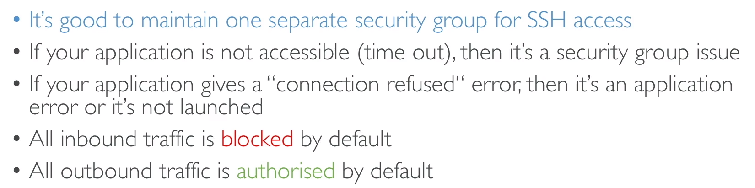

### 3.2.1 Classic Port to Know

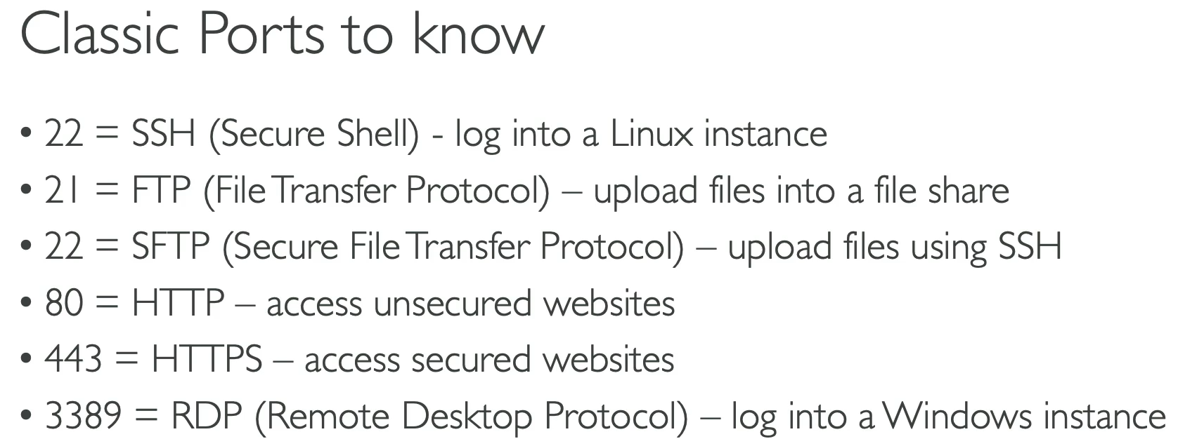

### 3.2.2. Inbound Rules

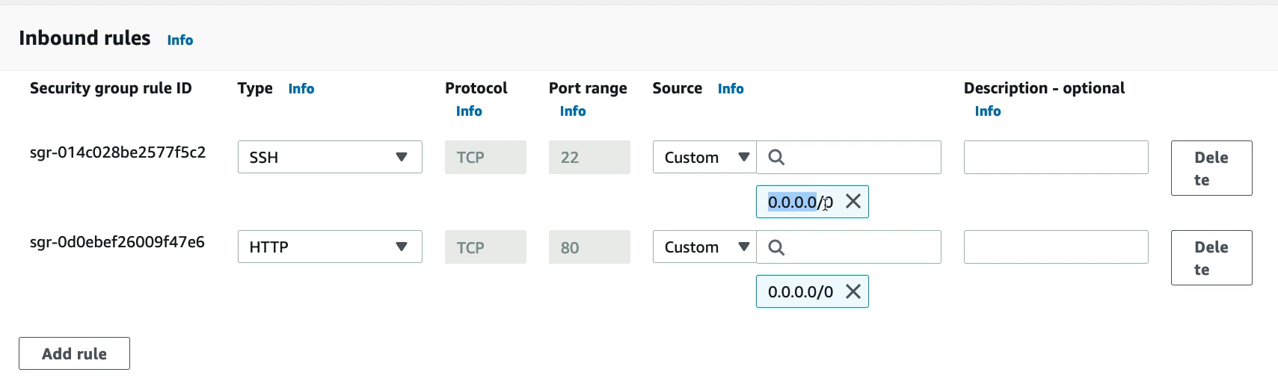

### 3.3.3 SSH

SSH – Not able to access for Windows < 10

Putty – Only allow Windows (Not Mac/ Linux)

EC2 Instance Connect – Allow all.

* Do not enter IAM API key (Secret) in EC2 Instance – Another user can retrieve.
* Add “IAM Role” to the Instance (IAM ReadOnly Access)

## 3.3 EC2 Instances Purchasing Options

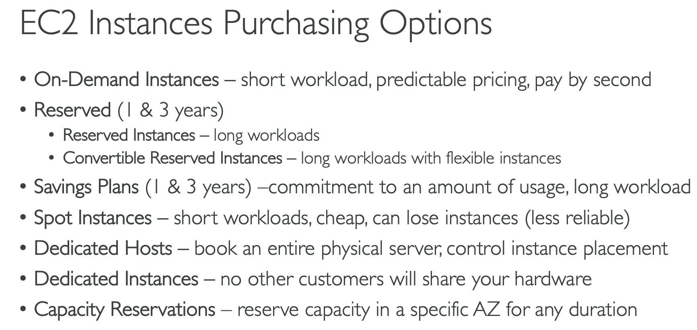

### 3.3.1 Reserved (1 / 3 years) – Lock to that instances

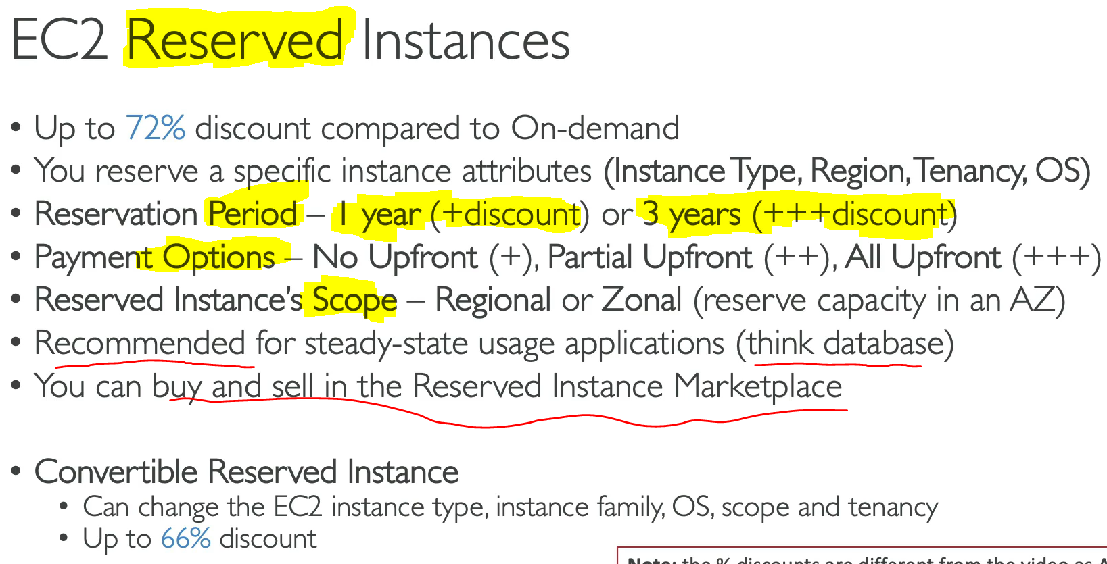

### 3.3.2 Saving (1 / 3 years) – Can upgrade Instance Size (Support Lambda)

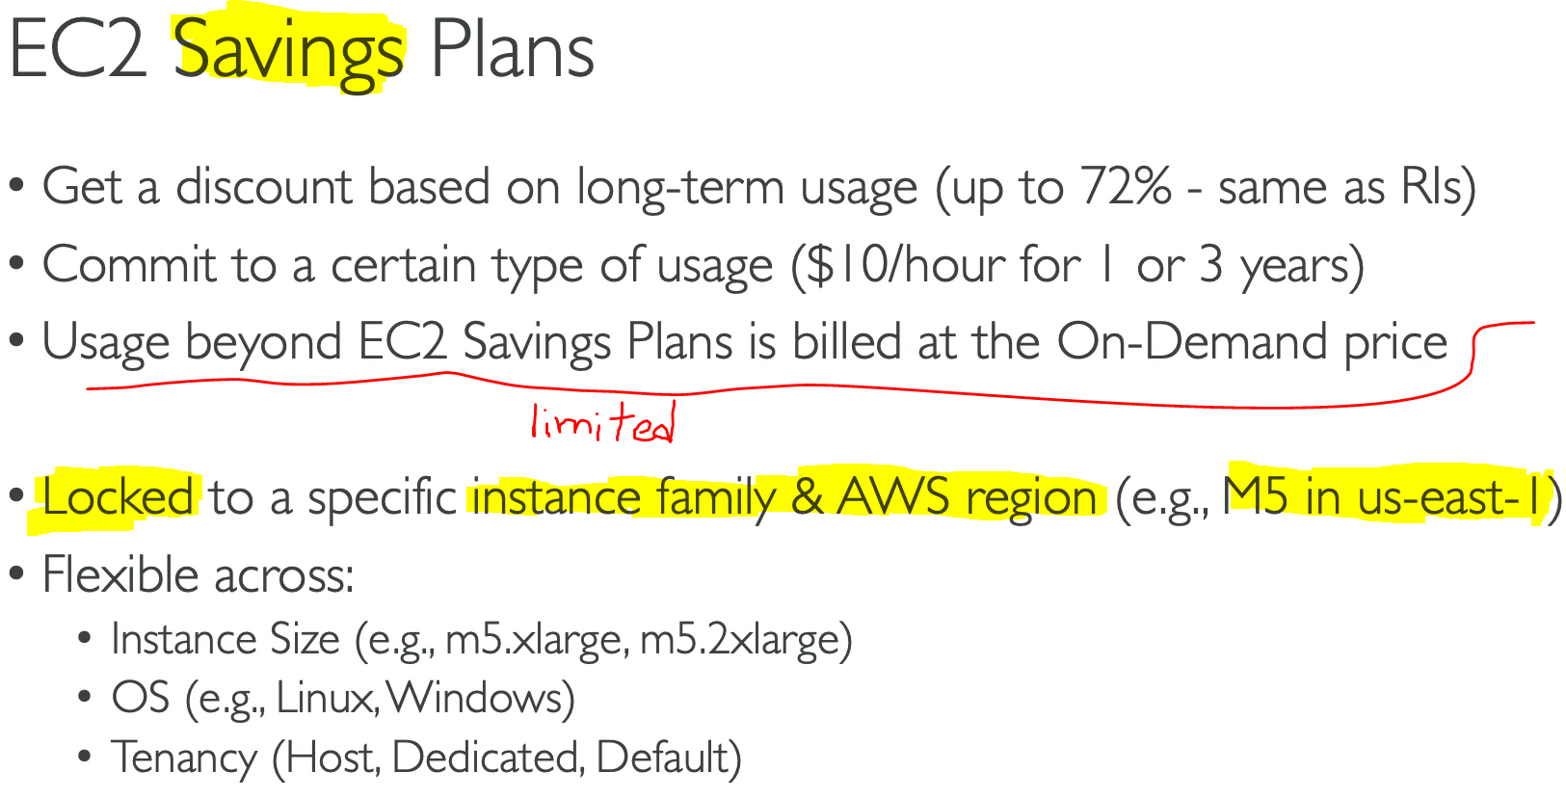

### 3.3.3 Spot (Cheapest)

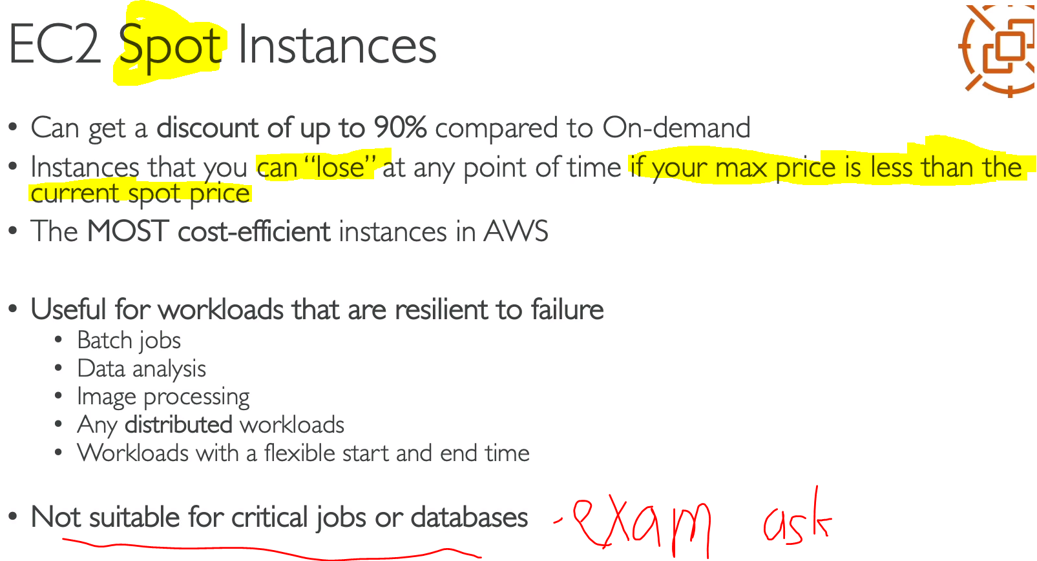

### 3.3.4 Dedicated Host (Most Expensive)

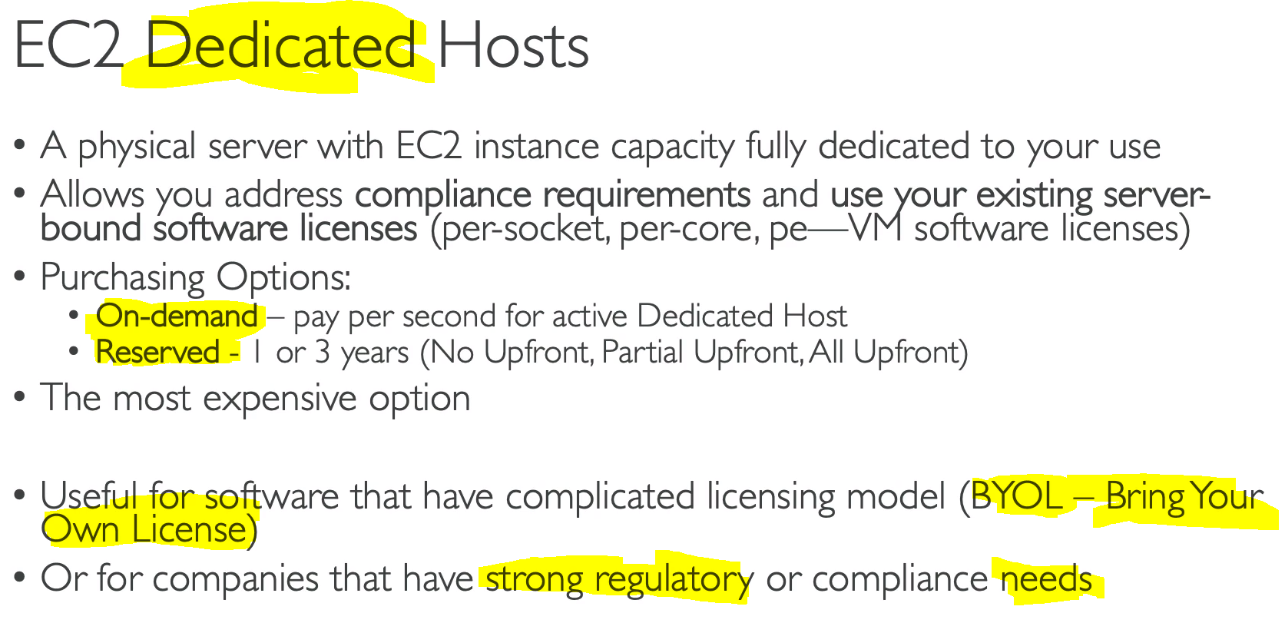

### 3.3.5 Dedicated Instances

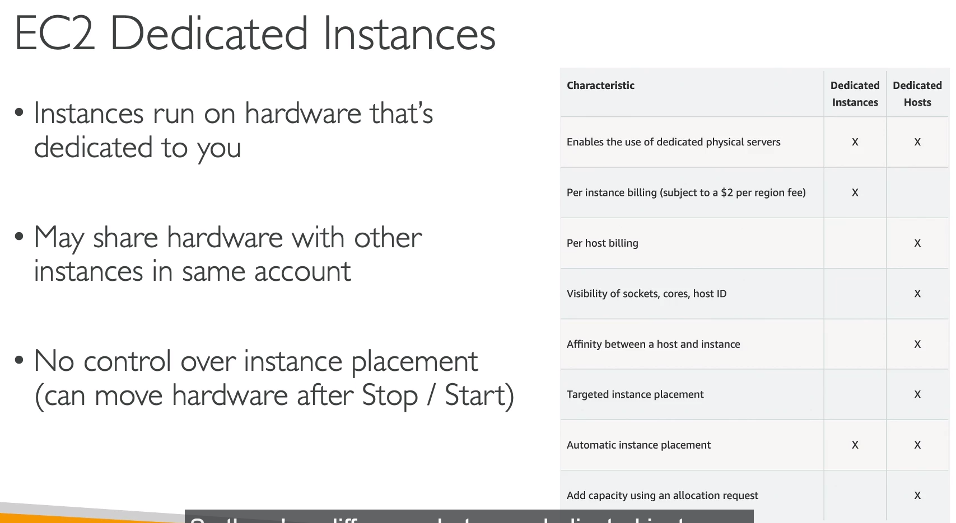

### 3.3.6 Capacity Reservations (No discount)

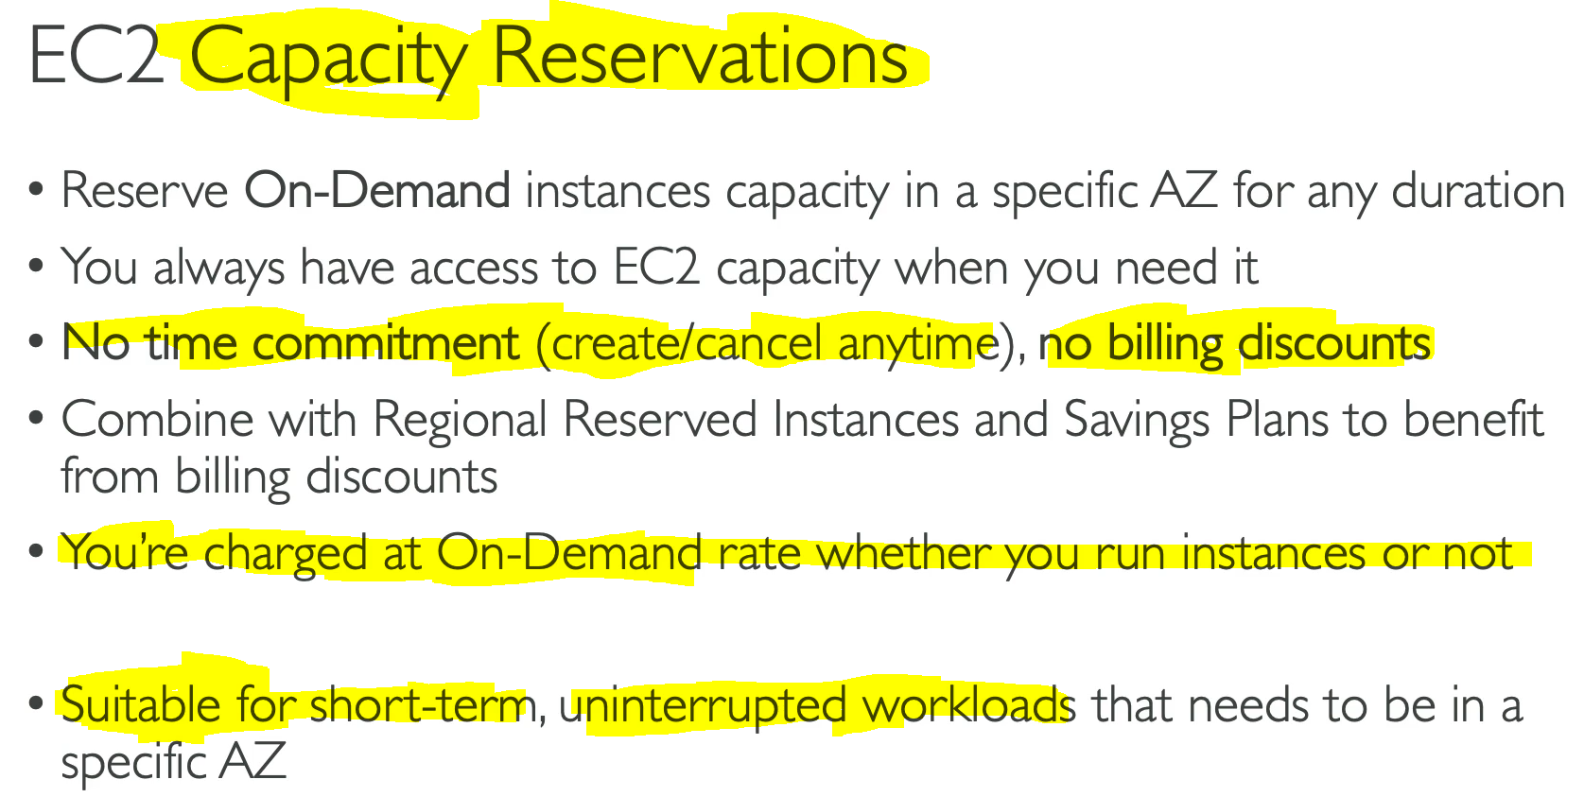

### 3.3.7 How to choose EC2 Instances

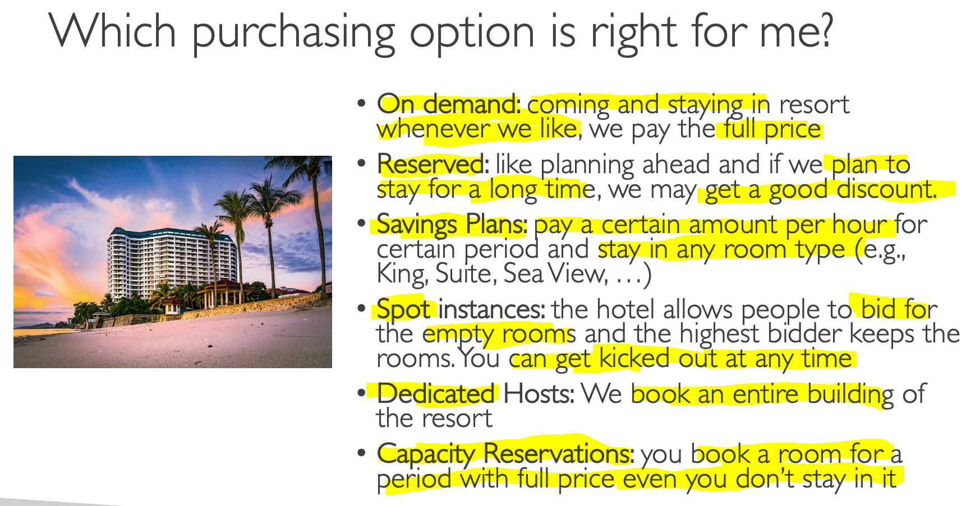

### 3.3.8 Price Compare Example

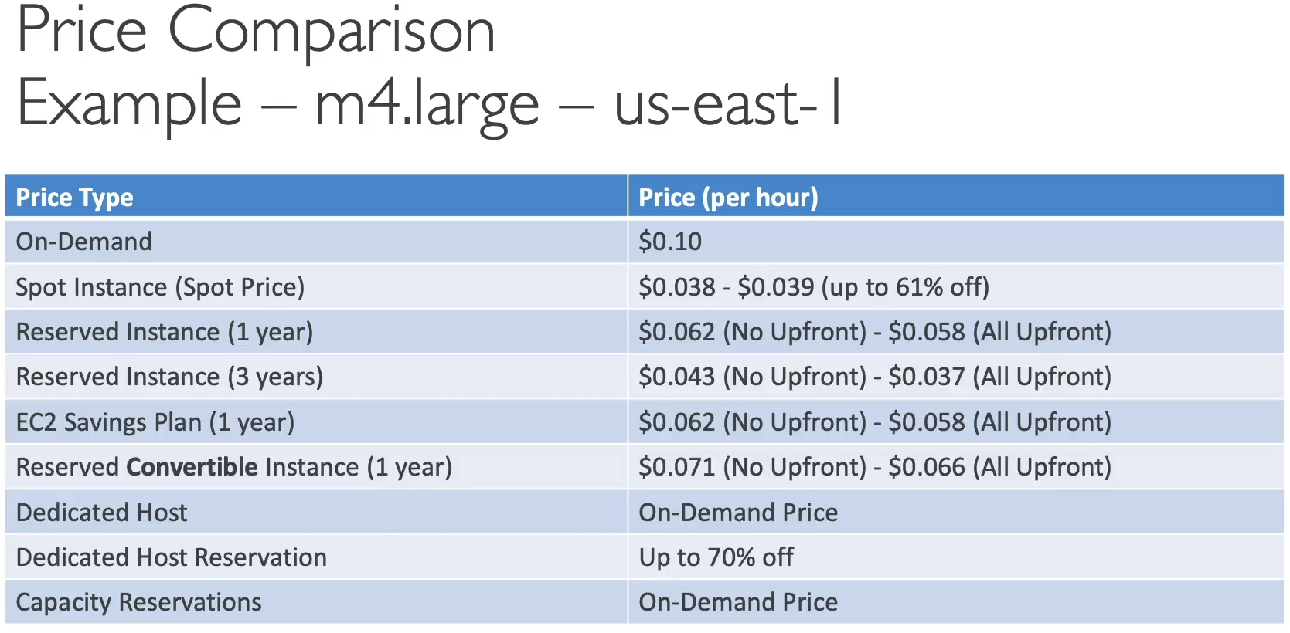

### 3.3.9 Sharing Responsibility Model

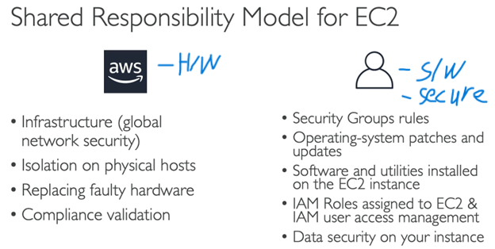

## 3.4 Hard Quiz

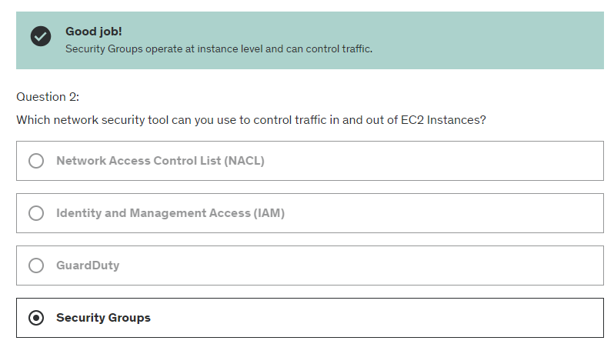

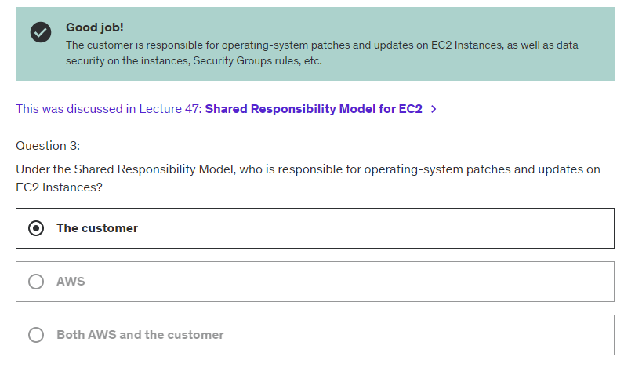

# Chapter 4: Elastic Block Store (EBS)

## 4.1 EBS Volume

* EBS Volume is a network drive you can attach to your instances.
* It only can be mounted to 1 instance at a time (CCP level)
* Bound to a specific availability zone. (AZ)

Think of them as a “network USB stick.”

If Volume (EBS) connect to different AZ, the volume can’t be run.

## 4.2 EBS Snapshots (Backup)

* Make a backup.
* Can copy snapshots across (to different) AZ/ Region

### 4.2.1 EBS Snapshots Achieve

* Move a Snapshot to an “achieve tier” that is 75% cheaper.
* Takes within 24 – 72 hours to restore.

### 4.2.2 Recycle Bin for EBS

* Setup rules to retain (restore) deleted snapshots.
* Specify retention (1 day to 1 year)

## 4.3 Amazon Machine Image (AMI)

* AMI is built for **a specific region.** (and can be copied across region)
* Can launch EC2 instances form:
  + Public AMI: AWS provided.
  + Own AMI: self-make and maintain.

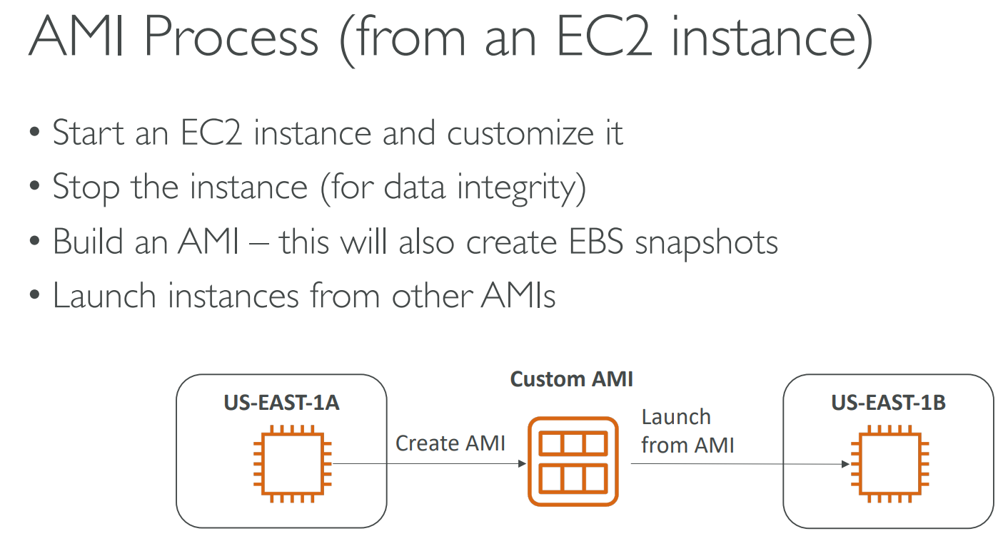

## 4.4 EC2 image Builder

* Used to automate creation of VM/ Container Image
* Automate creation, maintain, validate and test EC2 AMI

## 4.5 EC2 Instance Store

EBS volume good but “limited” performance.

* EC2 Instance Store is **high performance disk (exam- see high straight mean EC2 Instance Store)**
* Better I/O performance
* Lose storage if stopped.
* Good for buffer/ cache
* Risk of data loss
* Backup is own responsibility.

## 4.6 Elastic File System (EFS)

* EFS can be mounted on 100s of EC2.
* EFS works with LINUX EC2 instances in multi-AZ.
* High availability, scalability, expensive (3xgp2), pay per use, no capacity planning

### 4.6.1 EBS vs EFS

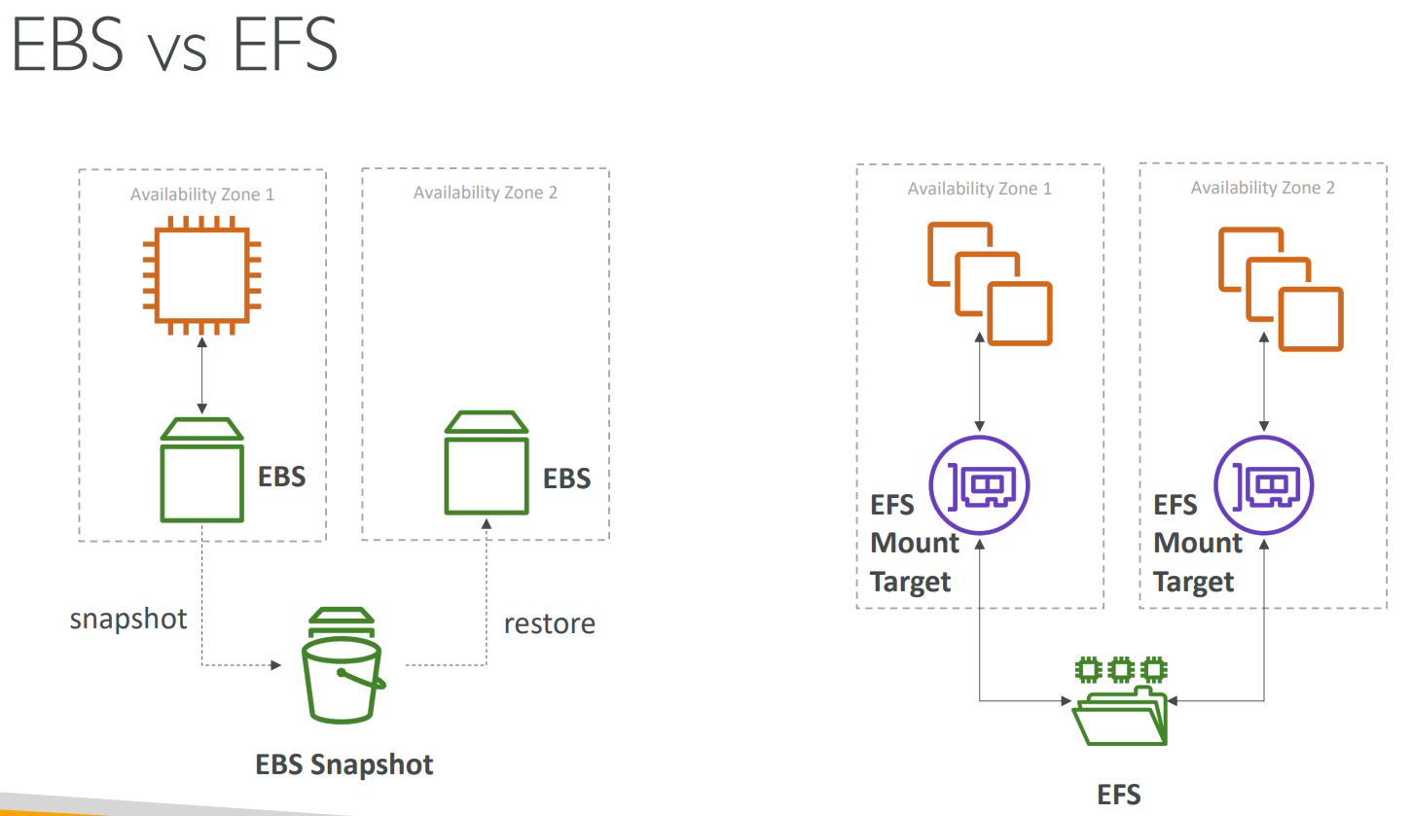

### 4.6.2 EFS Infrequent Access (EFS-IA) - <Cost Saving>

* Storage class (Cheap) (Not access every day)
* 92% cheaper than EFS Standard
* EFS will auto move files to EFS-IA (with Lifecycle Policy)
* Eg: Move files that not accessed for 60 days to EFS-IA

## 4.7 Amazon FSx

* To launch 3rd party high-performance file systems on AWS
* Eg:
  + FSx for Lusture (High Performance Computing – HPC)
  + FSx for Windows File Server
  + FSx for NetApp ONTAP

## 4.8 Hard Quiz

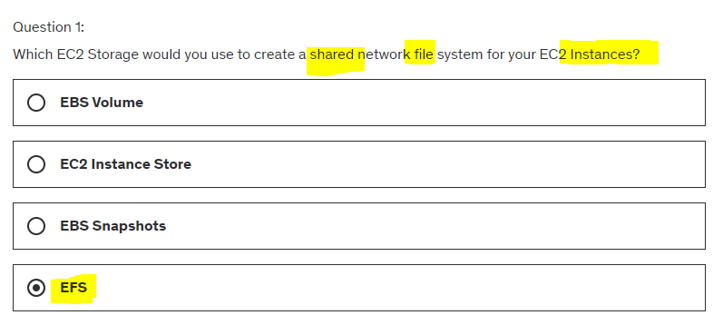

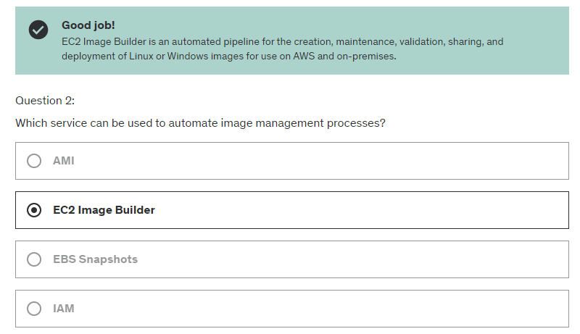

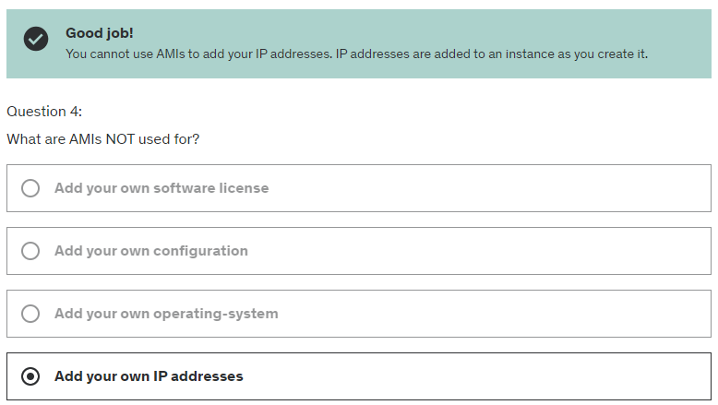

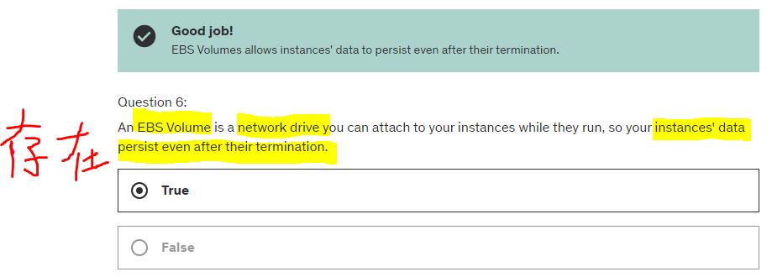

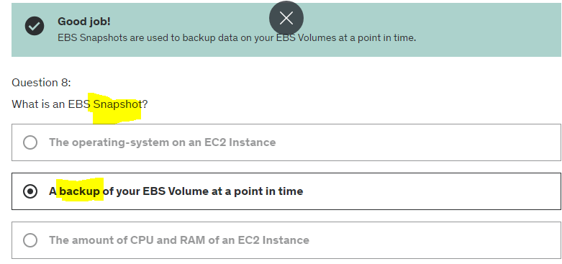

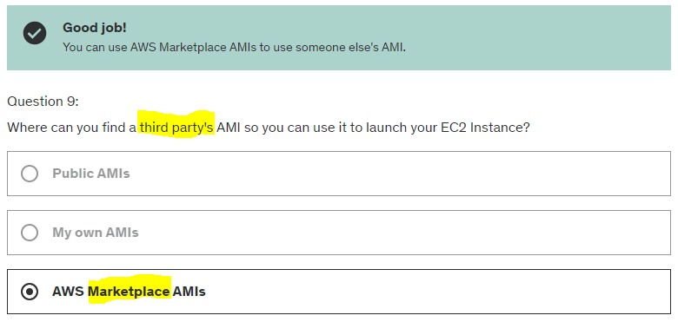

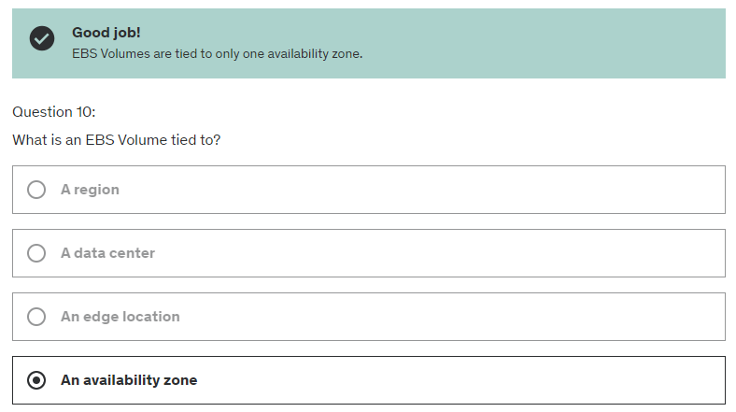

# Chapter 5: Elastic Load Balancing (ELB) & Auto Scaling Groups (ASG)

## 5.1 Scalability & High Availability (on EC2)

* Vertical Scalability
* Horizontal Scalability (=elasticity)

### 5.1.1 Vertical Scalability

* Vertical Scalability means increasing the size of the instance.
* From t2.micro -> t2.large
* Common for database
* Limit on how much can vertically scale (Hardware Limit)

### 5.1.2 Horizontal Scalability

* Increasing the amount of instances/ system for applications
* Implies to distributed system.
* Common for web app/ moder app

### 5.1.3 High Availability

* Usually go with horizontal scaling
* Run app in >= 2 AZ

## 5.2 Scalability vs Elasticity vs Agility

**Scalability**: ability to accommodate a larger load by making the h/w stronger (scale up) or by adding nodes (scale out)

**Elasticity**: once a system is scalable, elasticity = “auto-scaling” so that system can scale based on the load. This is “cloud-friendly”; pay per use, match demand, optimize cost

**Agility:** (not relate – distractor) reduce time to make those resources available to developers

## 5.3 Elastic Load Balancing (ELB)

* Load balancers are servers that forward internet to multiple servers (EC2 instances) downstream.
* Spread load across multiple downstream instances.
* Expose single point of access (DNS) to app.
* Seamlessly handle failure of downstream instances
* Do regular health checks.
* Provide SSL
* High AZ

4 kinds of LB in AWD

* App Load Balancer (HTTP/HTTPS) – Layer 7
* Network Load Balancer (Ultra High Performance, allow TCP) – Layer 4
* Gateway Load Balancer – Layer 3
* Classic Load Balancer (no exist more) – Layer 4 & 7

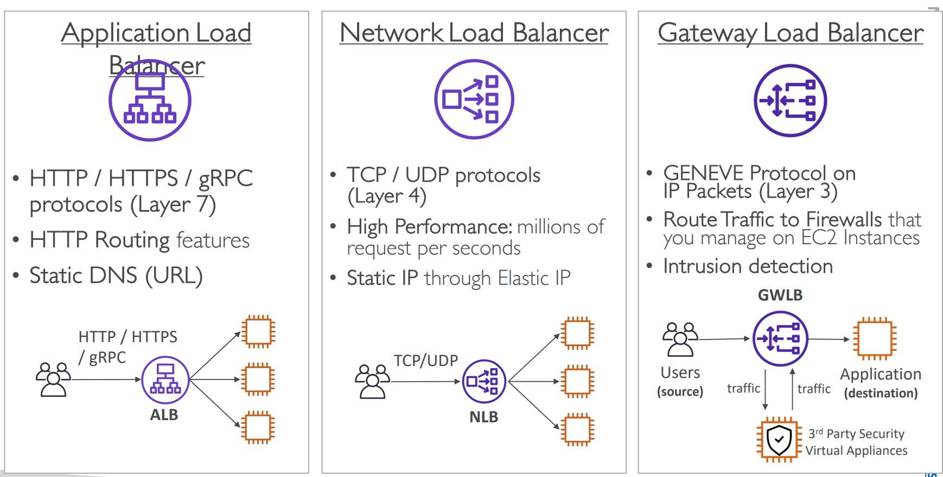

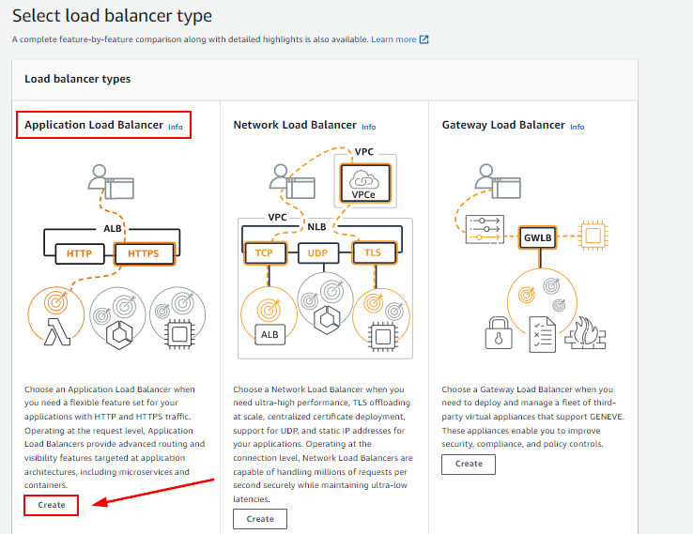

### 5.3.1 Auto Scaling Group (ASG)

Scale Out (add E2 instances)

Scale In (Remove EC2 instances)

* Will automatically detect unhealthy instances and create new one to replace.

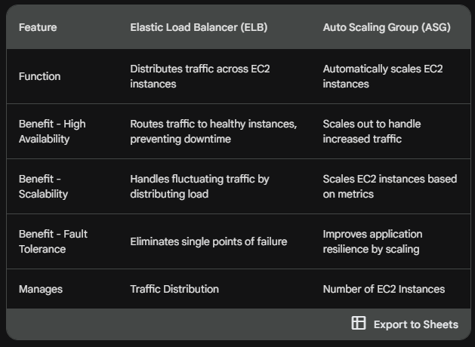

### 5.3.2 Scaling Strategy

* Manual Scaling: Update size of ASG manually
* Dynamic Scaling: Respond to changing demand
  + Simple/ Step Scaling
    - When CloudWatch alarm triggered (CPU >70%), then add 2 units.
    - When (CPU < 30%), remove 1
  + Target Tracking Scaling
    - Scale to stay around 40%.
  + Scheduled Scaling
    - Increase on 10pm (Peak hour)
  + Predictive Scaling
    - Use ML to predict future traffic.

## 5.4 Hard Quiz

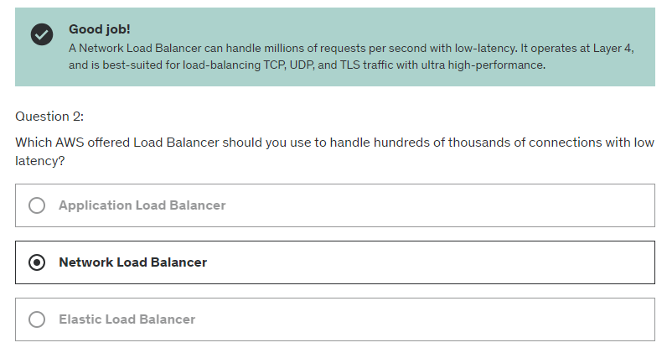

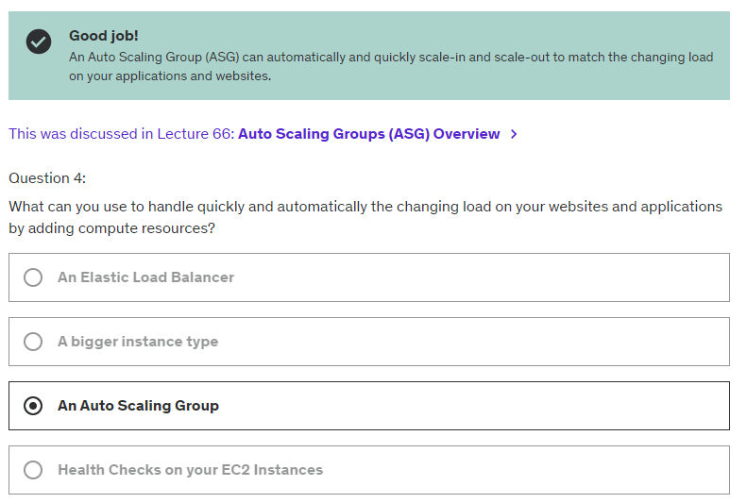

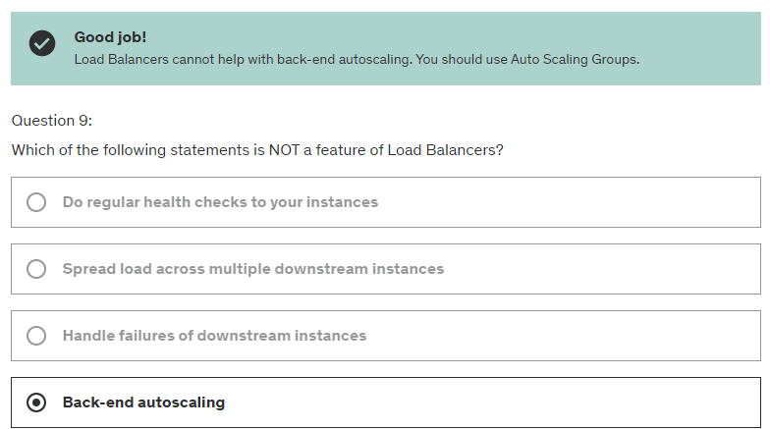

# Chapter 6: Amazon S3 (S3 = Storage)

“Infinitely Scaling” Storage

## 6.1 S3 Use case.

* Backup (Bucket Replication) and Storage
* Disaster Recovery
* Achieve
* Hybrid Cloud Storage
* Application hosting
* Data lakes & big data analytics
* Static website

## 6.2 Amazon S3 – Buckets

* Allow people to store object (files) in buckets (directories)
* Must have a globally unique name.
* Buckets defined at region level (even it looks like global service)
* Naming conventions
  + No uppercase, No underscore
  + 3 -63 characters long
  + Not IP
  + Must start with lowercase letter or number.
  + Must NOT start with the prefix xn—
  + Must NOT end with suffix -s3alias.

### 6.2.1 Objects

1. Objects (files) have a Key.
2. **Key** is the **FULL** path.

* s3://mybucket/my_file.txt
* s3://mybucket/my_folder/another_folder/my_file.txt

1. The key is composed of **prefix** + **object name.**

* s3://mybucket/my_folder/another_folder/my_file.txt

1. There is no concept of “directories” within buckets
2. It is just **KEY.**
3. Max Object size 5TB
4. Max Upload Size 5GB

## 6.3 Amazon S3 -Security

### 6.3.1 User Based

IAM Policies – which API calls should be allowed for specific user from IAM

### 6.3.2 Resource-Based

* Bucket Policies – bucket wide rules from S3 console – slows cross account.
* Object Access Control List (ACL) finer grain (can be disabled)
* Bucket ACL – less common (can be disabled)

IAM principal can access S3 object if:

* User IAM permission ALLOW.
* Resource policy ALLOWS.
* No explicit DENY.

## 6.4 S3- Static Web Hosting

Website URL:

* http://bucket-name.s3-website-aws-region.amazonaws.com

Eg: http://demo-bucket.s3-website-us-west-2.amazonaws.com

If get **error 403**, make sure bucket policy **allows public reads**.

## 6.5 S3 Storage Classes

### 6.5.1 Amazon S3 Standard – General Purpose

* Durability - High (99.9999999999%) – wont loss single object
* Availability – 99.99% availability = not available 53 minutes a year
* Use case: Big Data analytics, mobile gaming app, content distribution.

### 6.5.2 Amazon S3 Standard-Infrequent Access (IA)

* Availability – **99.9%** availability (Less Standard 0.09%)
* Use case: Disaster Recovery, Backups.

### 6.5.3 Amazon S3 One Zone-Infrequent Access

* Durability - High (99.9999999999%) – wont loss single object
* Availability – **99.5%** availability
* Use case: Secondary Backup copies of on-premise data.

### 6.5.4 Amazon S3 Glacier Instant Retrieval

Glacier = Low-cost object storage meant for caching / backup

Pricing: Pricing for storage + object retrieval cost

* Millisecond retrieval, great for data accessed once a quarter.
* Minimum storage duration of 90 days

### 6.5.5 Amazon S3 Glacier Flexible Retrieval

* Expedited (1-5 mins), Standard (3-5 hrs), Bulk (5-12 hrs) – Free
* Minimum storage duration of 90 days

### 6.5.6 Amazon S3 Glacier Deep Archive

* Standard (12 hrs), Bulk (48 hrs)
* Minimum storage duration of 180 days

### 6.5.7 Amazon S3 Intelligent Tiering

1. Small monthly monitoring and auto-tiering fee
2. Moves object auto between Access Tiers based on usage.

* Frequent Access tier (auto) : Default
* Infrequent Access tier (auto) : Object not access for 30 days
* Archive Instant Access tier (auto) : Object not access for 90 days
* Archive Access tier (optional) : configurable from 90 – 700 + days
* Deep Archive Access tier (optional): configurable from 180 – 700 + days

## 6.6 S3 Encryption

Server-Side Encryption **(Default)**

* Server encrypts the file after receiving it

Client-Side Encryption

* User encrypts the file before uploading it

## 6.7 IAM Access Analyzer for S3 (ACLs = S3 security)

* Ensure only intended people access to S3 buckets.
* Eg: Public accessible bucket, bucket shared with other AWS acc
* Evaluates S3 Bucket Policies, S3 ACLs, S3 Access Point Policies

Powered by IAM Access Analyzer

## 6.8 AWS Snow Family (Hardware devices)

* Highly secure, portable devices
* Collect and process data at the edge.
* Migrate data into and out of AWS.

1. Data migration

* Snowcone – Light (2.1 Kg) , 24TB
* Snowball Edge – TB/ PB
* Snowmobile – EB (1000PB) , truck to your house

1. Edge Computing
   * Snowcone
   * Snowball Edge

Challenges (can be overcome by Snowball)

* Slow transfer speed (1PB – takes 3 years if 100 Mbps)
* High network cost
* Connection stability

## 6.9 Edge Computing

Edge Location example:

* Truck on road
* Ship on sea
* Mining station underground

Characteristics:

1. Limited/No internet access
2. Limited/No access to computing power

Solution:

* Snowball Edge
* Snowcone
* Snowcone SSD (Smaller than Snowcone)

## 6.10 OPsHub

* A desktop application to manage Snow Family Devices

## 6.11 AWS Storage Gateway

* Hybrid Storage service that allows on-premises to seamlessly use AWS Cloud
* gateway types supported: **Tape Gateway, File Gateway and Volume Gateway**

## 6.12 Hard Quiz

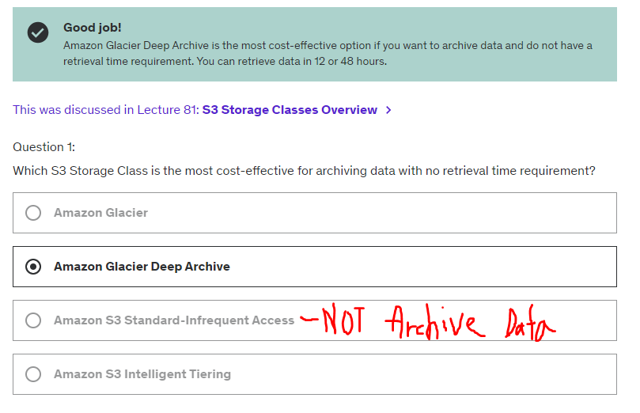

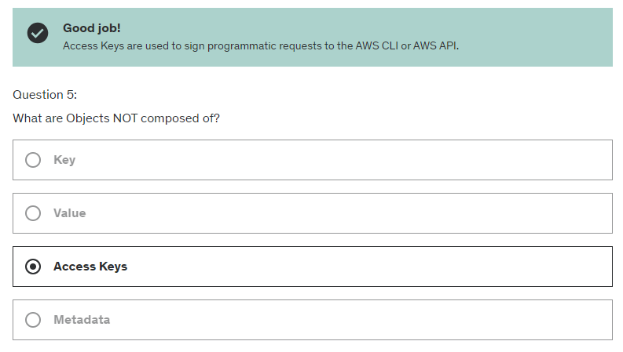

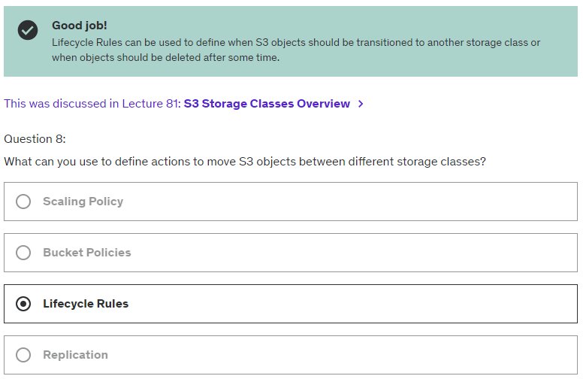

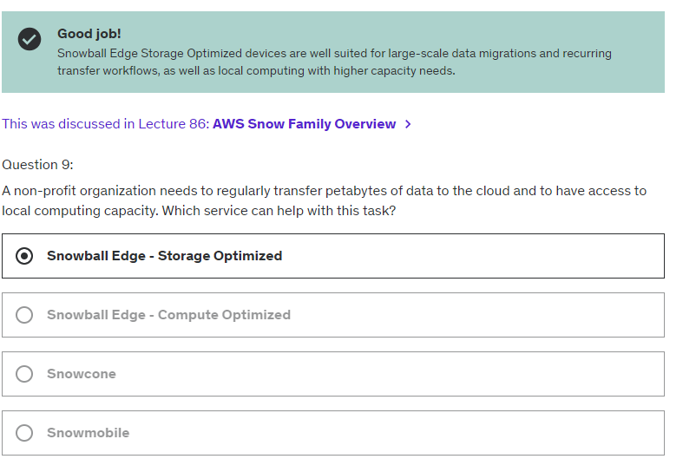

# Chapter 7: Database (RDS = Database)

## 7.1 Relational Database Service (RDS) - Server

Manage DB that use SQL

Advantage of RDS:

* Automated provisioning, OS patching
* Continuous backups
* Monitoring dashboards
* Read replicas for improved read performance.
* Multi AZ setup for DR (Disaster Recovery)
* Maintenance windows for upgrades
* Scaling capability (vertical and horizontal)
* Storage backed by EBS.

BUT we cannot SSH into our instances (database)

## Amazon Aurora - Server

* Proprietary Technology from AWS (not open source)
* 5x performance improvement over MYSQL on RDS, 3x performance improvement for Postgres on RDS
* Auto grow in increments of 10GB, up to 128 TB
* Aurora cost more than RDS (20% more) – but more efficient
* Not in free tier

### 7.2.1. Aurora Serverless

* No capacity planning need
* Least management overhead
* Pay per second
* Use cases: Good for infrequent, intermittent or unpredictable workloads.

## 7.3 RDS Deployments

### 7.3.1 Read Replicas

* Scale the Read Workload of DB
* Max 15 Replicas
* Data only written to main DB

### 7.3.2 Multi-AZ

* High Avaliability
* Replication cross AZ

### 7.3.3 Multi-region

* Disaster recovery
* Local performance
* But replication costly

## 7.4 Elastic Cache (In-memory DB)

* To get manage Redis/ Memcached
* Reduce load of DB (READ operation)

## 7.5 Dynamo DB (NoSQL)

* Replication across 3 AZ
* “Serverless” DB
* Single digit ms latency (low latency)
* Key/value DB

### 7.5.1 DynamoDB Accelerator – DAX

* In memory DB for DynamoDB
* Only used for DynamoDB, Not like “Elastic Cache” is for all other DB

### 7.5.2 DynamoDB - Global Table

* Make a table with Low Latency across multiple region

## 7.6 Redshift (Data warehouse)

* Postgres, not for OLTP
* OLAP (online analytical processing)
* Load data once every hour
* 10x better performance to other data warehouse
* Column storage data
* BI tools such as AWS Quicksight
* Support query (SQL)

## 7.7 Elastic MapReduce (EMR)

* **Hadoop Cluster (Big data)**
* Use case: Data processing, ML, big data

## 7.8 Amazon Athena (Serverless SQL)

* **Serverless query service** to perform analytics against S3 object
* Use standard SQL
* Support CSV, JSON

## 7.9 Amazon QuickSight (Reporting Dashboard)

* Serverless ML BI to create interactive dashboard
* Fast, auto scale
* Integrated with RDS, Aurora, Athena, Redshift, S3

## 7.10 DocumentDB (JSON - MongoDB)

* Aurora is “AWS implementation” of PostgreSQL / MySQL
* DocumentDB is for MongoDB (NoSQL DB)

## 7.11 Amazon Neptune

* **Graph** DB
* Eg: Social network

## 7.12 Amazon Timestream

* Time Series Data
* Auto Scale up/down

## 7.13 Amazon Quantum Ledger Database (QLDB)

* Book recording **Financial Transaction**
* Immutable: blockchain
* 3x faster than common ledger blockchain framework
* Manipulate data using SQL
* No concept of decentralized

## 7.14 Amazon Managed Blockchain

* Blockchain = decentralized

## 7.15 AWS Glue

* **Manage extract, transform, and load (ETL)**
* Fully serverless service

## 7.16 Database Migration Service (DMS) DB -> DB

* Quick & Secure migrate database to AWS
* Support Homogenous migration: Oracle to Oracle
* Support Heterogeneous migration: Microsoft SQL Server to Aurora

# Chapter 8: Other Compute Service

## 8.1 Elastic Container Service (ECS)

* Launch **Docker** on AWS
* Role (Self): Provision and Maintain infrastructure (EC2 instances)
* Role (AWS): Take care Start/ Stop container.
* Already Integrated with Application Load Balancer

### 8.1.1. Fargate (Serverless)

* No need Maintain infrastructure (EC2 instances) anymore

### 8.1.2 Elastic Container Registry (ECR) – Docker Image

* Private Docker Registry on AWS
* Where we store the **Docker Image**

## 8.2 AWS Lambda (Serverless)

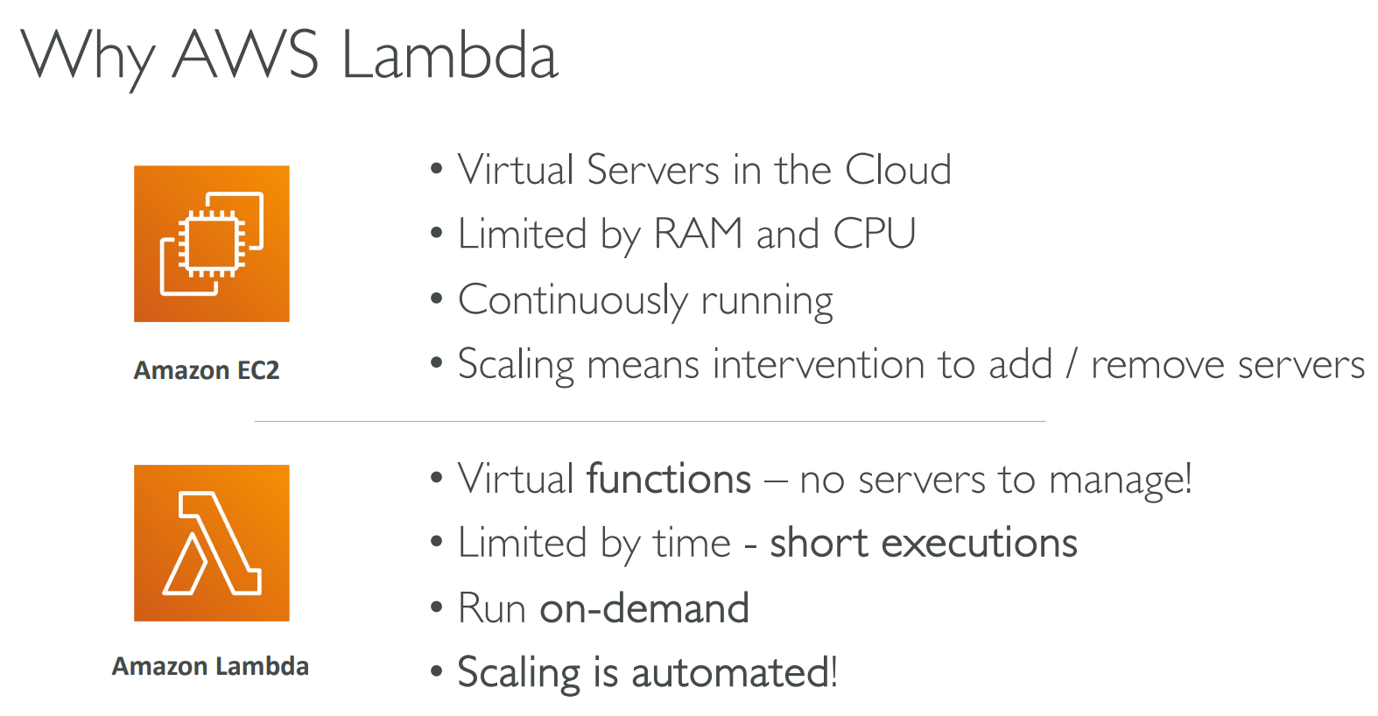

Eg: Serverless Thumbnail creation

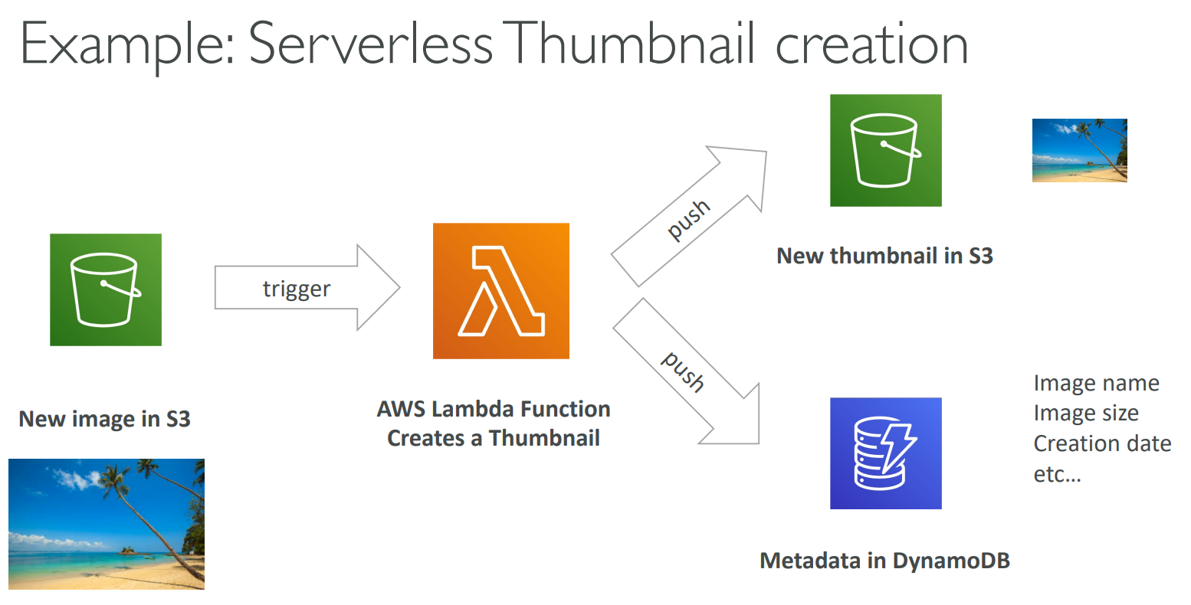

* Time Limit : 15 minutes
* Charge per call and per duration
* Not Support Docker

## 8.3 AWS Batch (Server)

* Has a point of time what happen (0100 – 0300)
* Dynamically launch **EC2 instances & Spot Instances**
* We just need schedule batch job, and AWS batch do the rest
* Batch Job defined as **Docker Images** and run on ECS
* No Time Limit
* Relies on EC2 (Server)

## 8.4 Amazon Lightsail (Beginner)

* Virtual servers/ storage/ database
* Low price
* Simpler alternative to EC2, RDB, …
* Great for ppl with little cloud experience
* High availability
* Low Scalability

## 8.5 Hard Quiz

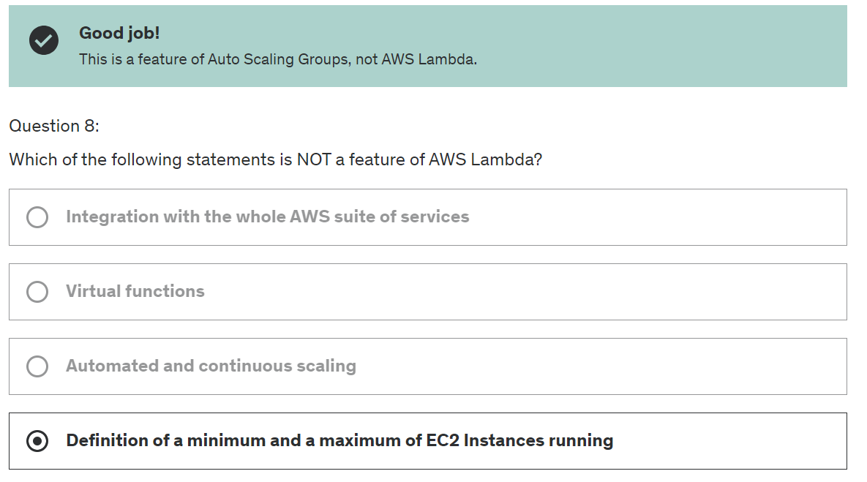

# Chapter 9: Deployment & Manage Infrastructure

## 9.1 Cloud Formation

Files in : YAML/ JSON

Eg:

1. I want a security group
2. I want 2 instances using the security group
3. I want a S3 bucket
4. I want a Load Balancer (ELB) in front of this machine

Cloud Formation creates those for you, **in the right order, and exact configuration**

* No resources are manually configured
* Changes to the infrastructure are reviewed through code
* Savings strategy: delete template on 8pm and recreate at 5am

Eg: **WordPress CloudFormation Stack**

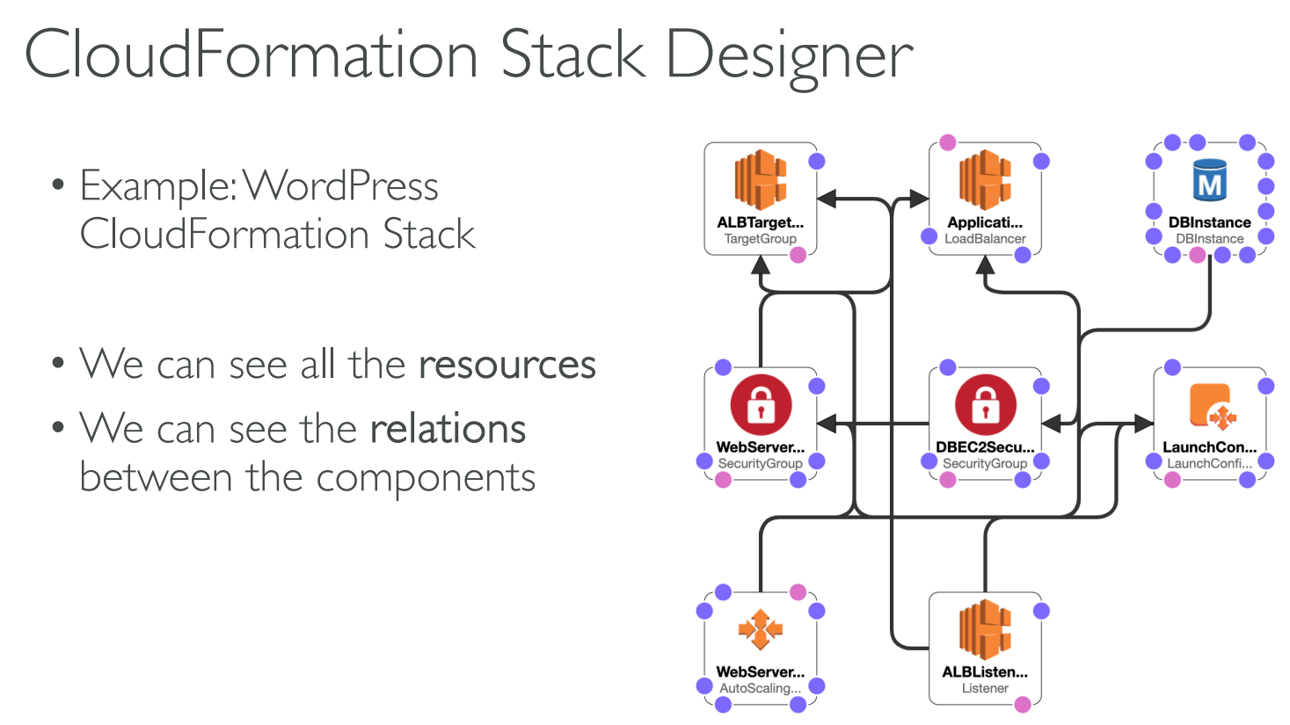

## 9.2 AWS Cloud Development Kit (CDK)

* Language: Java/ JS/ Python/ .NET
* Later will be compiled to YAML/ JSON (CloudFormation template)

## 9.3 Beanstalk (PaaS)

Developer problem

* Managing infrastructure
* Deploying Code
* Configuring DB, Load Balancer
* Scaling concern

With **Beanstalk,** developer just need to manage app code

3 architecture models:

* Single Instance deployment
* LB + ASG (Auto-Scaling Group) : good for production or pre-production
* ASG only: great for non web app in production (worker)

### 9.3.1 Health Monitoring (CloudWatch)

* Health agent push metric to CloudWatch
* Checks for app health
* Publish Health event.

## 9.4 CodeDeploy

* Deploy code automatically (Code only)
* Eg: Upgrade app from v1 -> v2

## 9.5 CodeCommit

* Source-control service
* Code changes are automatically versioned

## 9.6 CodeBuild

* Compile, run and test the code on Cloud
* Create Ready-to-Deploy Artifact in the end

## 9.7 CodePipelines

* Orchestrate different steps to have code automatically push to production
* Eg: Code => Build => Test => Provision => Deploy
* Basic for CI/CD

## 9.8 CodeArtifact (Dependency)

* Place to store code dependencies
* Tools: Maven, Gradle, npm, pip, yarn
* Developers & CodeBuild can retrieve dependencies straight from CodeArtifacts

## 9.9 CodeStar / CodeCatalyst (UI)

* Unified UI to allow developer to do CI/CD

## 9.10 Cloud9 (IDE)

* Cloud IDE

## 9.11 AWS System Manager (SSM)

* Way to patch a fleet of EC2 instances or On-Premise servers
* Run command across entire servers

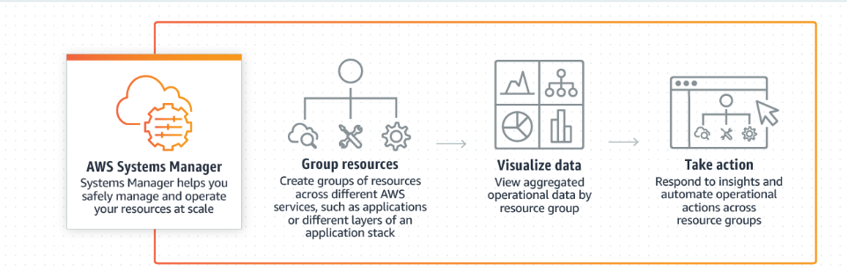

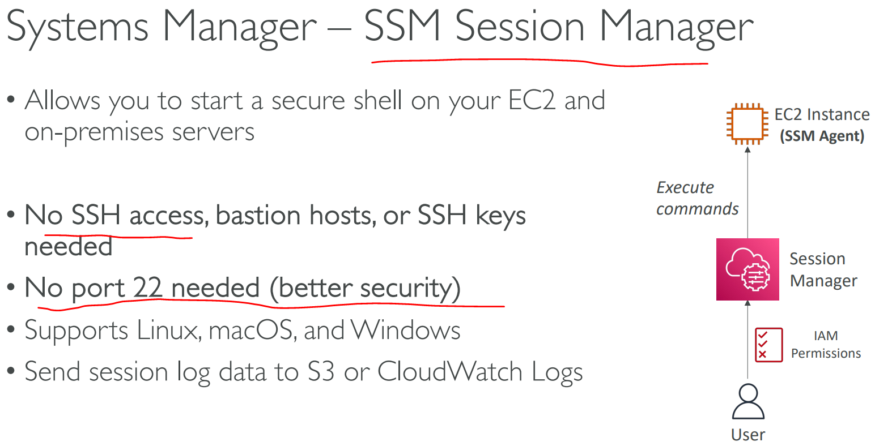

## 9.12 Hard Quiz

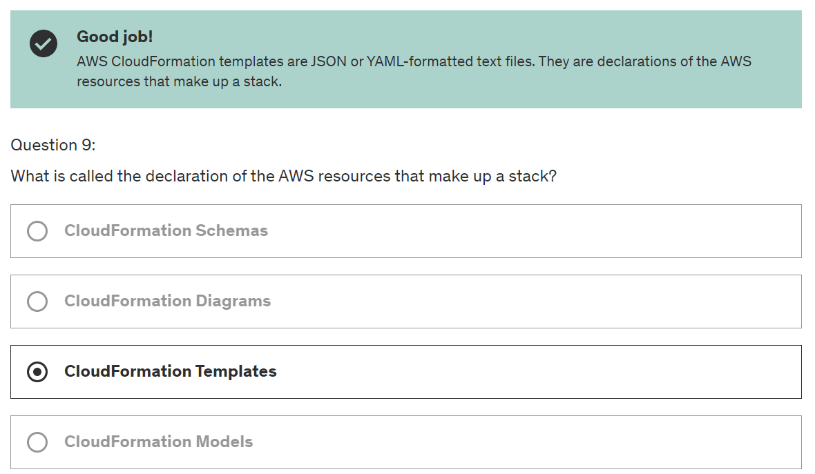

# Chapter 10: AWS Global Infrastructure

## 10.1 Why Global Infrastructure

* Decrease latency (Eg: Asia slow if connect to US)
* Disaster Recovery (DR) – Earthquake, Power cut
* Attack Protection – Hacker

## 10.2 Route 53 (Managed DNS)

* Domain Registration, DNS, Health Checks, Routing Policy

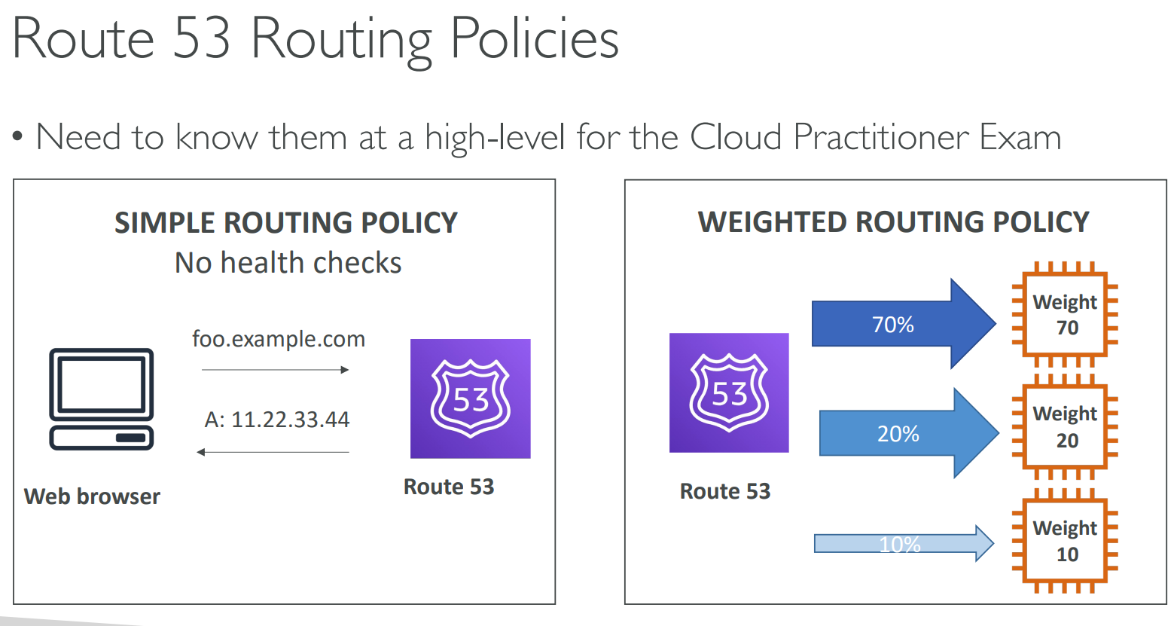

## 10.3 CloudFront (Content-Delivery Network)

* Content-Delivery Network (CDN)
* Improve READ, by caching content on Edge Location
* DDOS protection

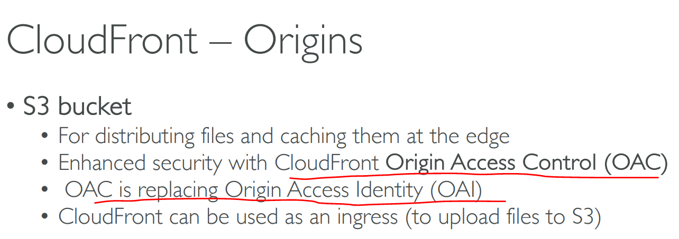

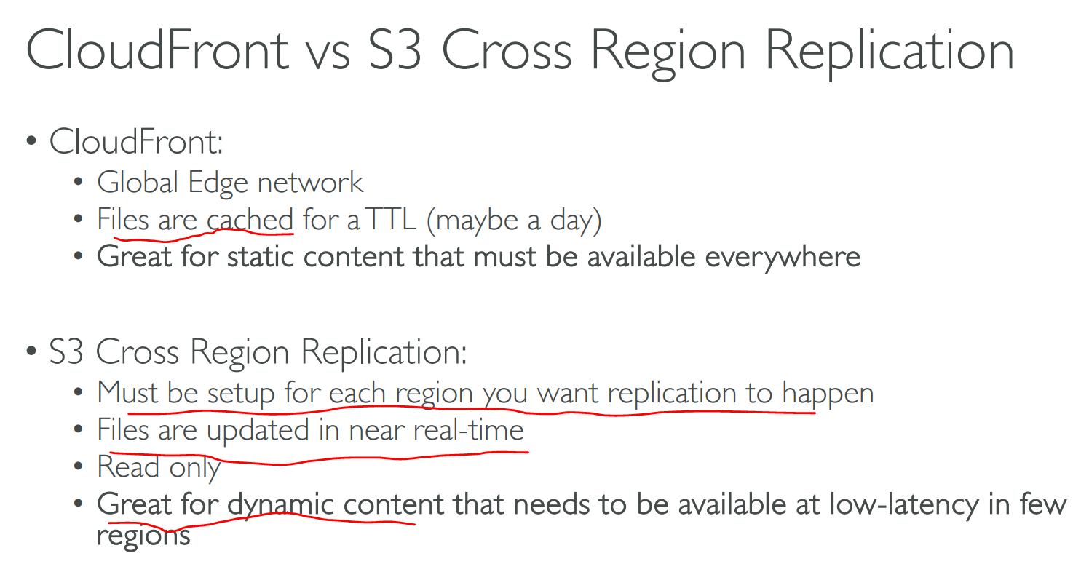

## 10.4 S3 Transfer Acceleration (S3 Edge Location Boost)

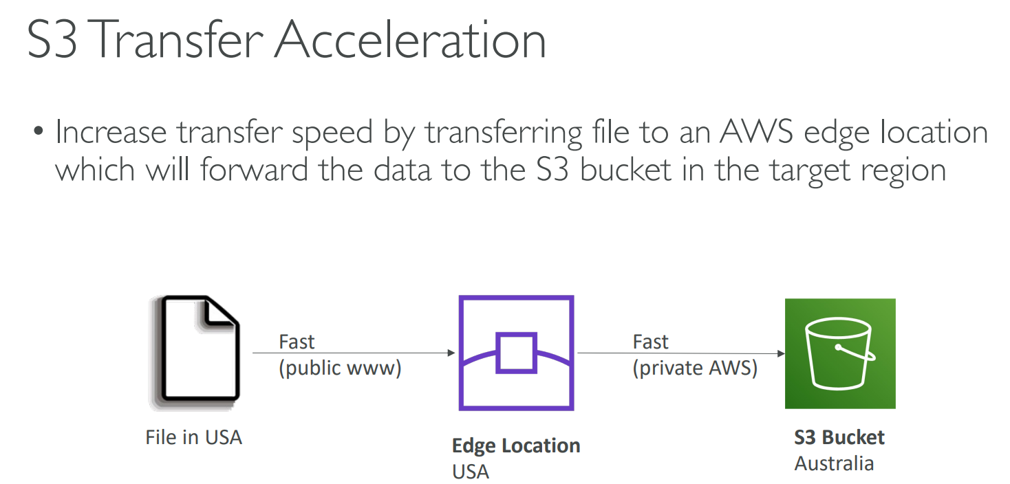

## A diagram of a diagram of a network Description automatically generated10.5 AWS Global Accelerator

* Improve Global availability and performance.
* Edge Location ------>
* 2 Anycast IP is created for app and traffic is sent through the Edge Location

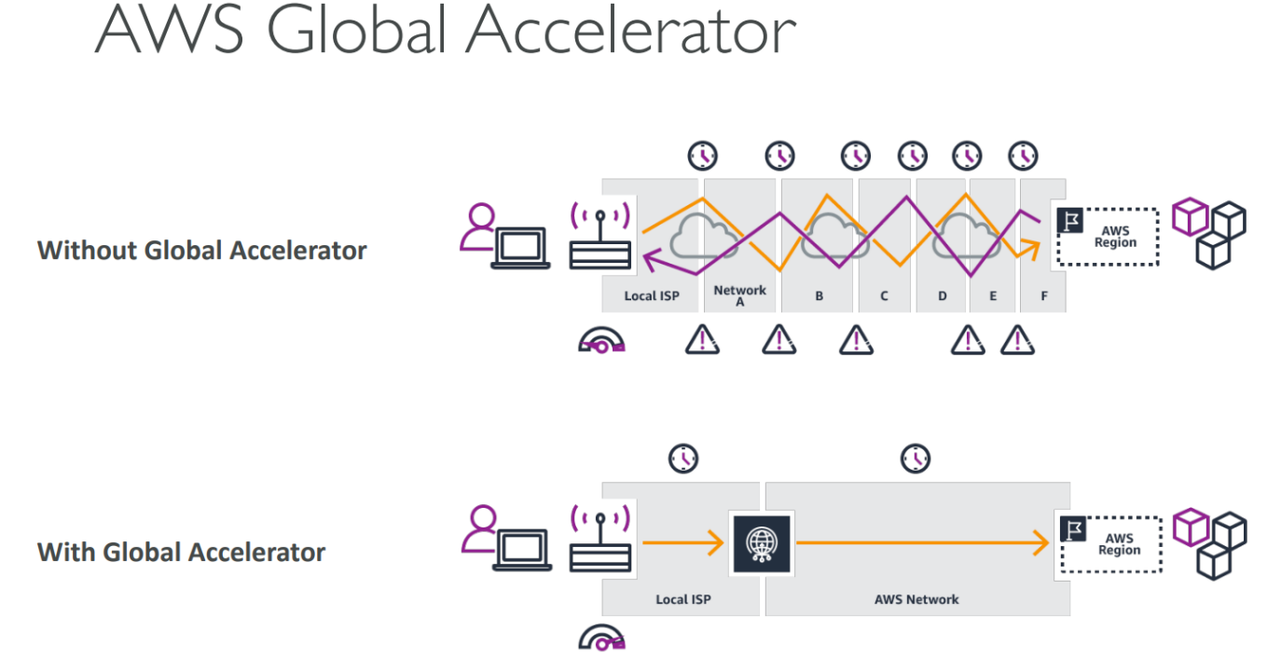

## 10.6 AWS Outposts (AWS Server to Office)

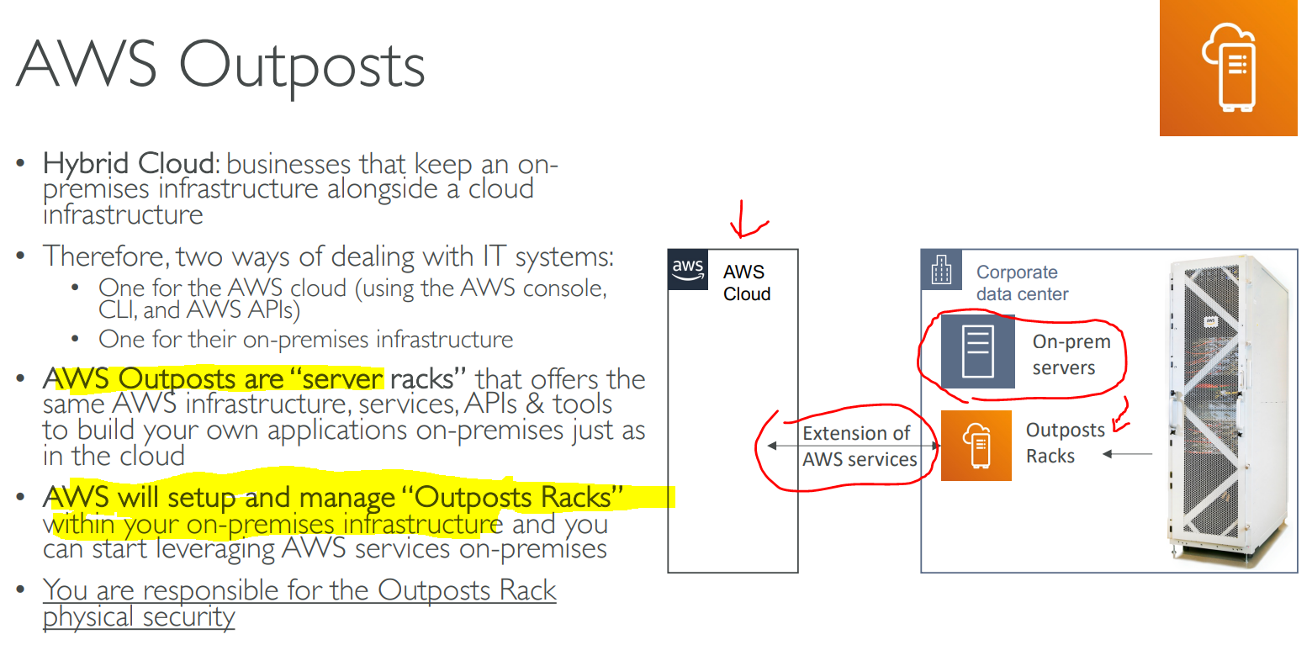

Benefits:

* Low latency access to on-premises system
* Easier migration from on-premises to cloud
* Data residency

## 10.7 AWS WaveLength (5G)

* Anything related to 5G

## 10.8 Global Application Infrastructure

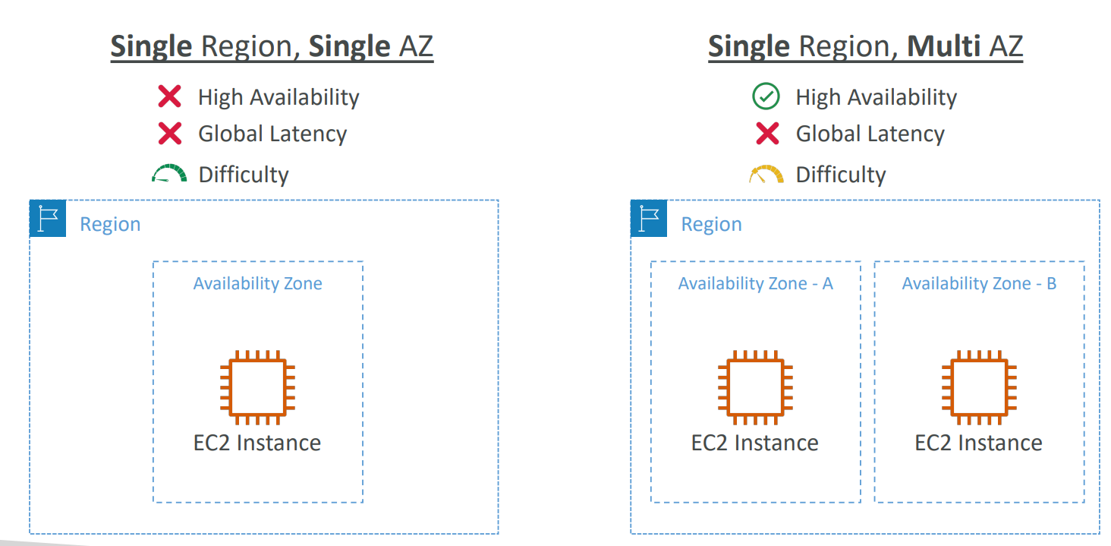

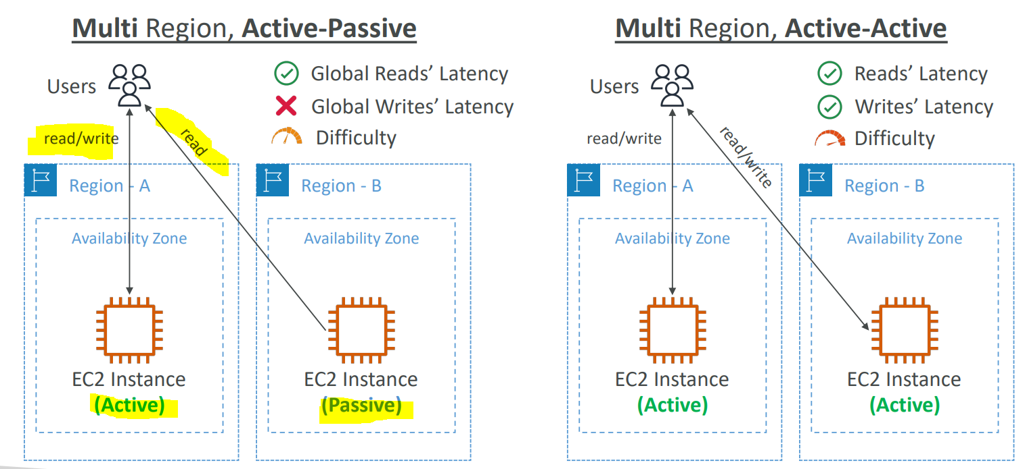

## 10.9 Hard Quiz

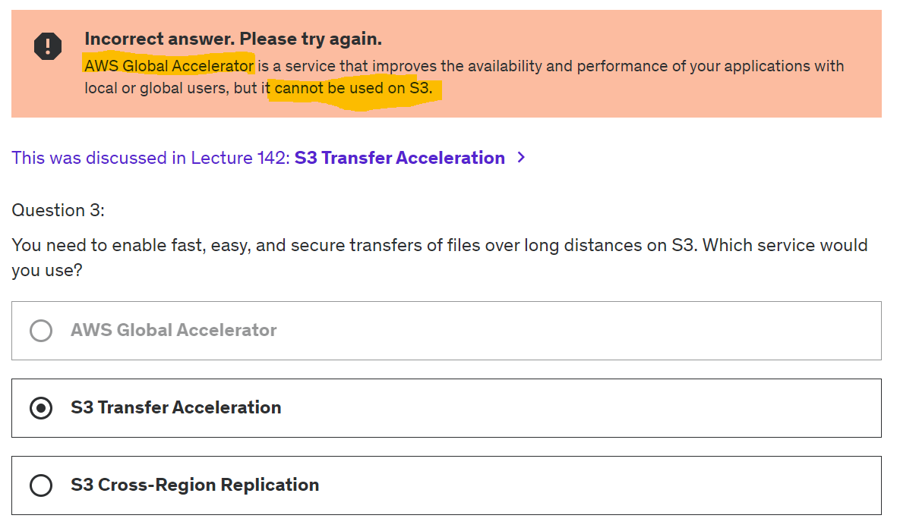

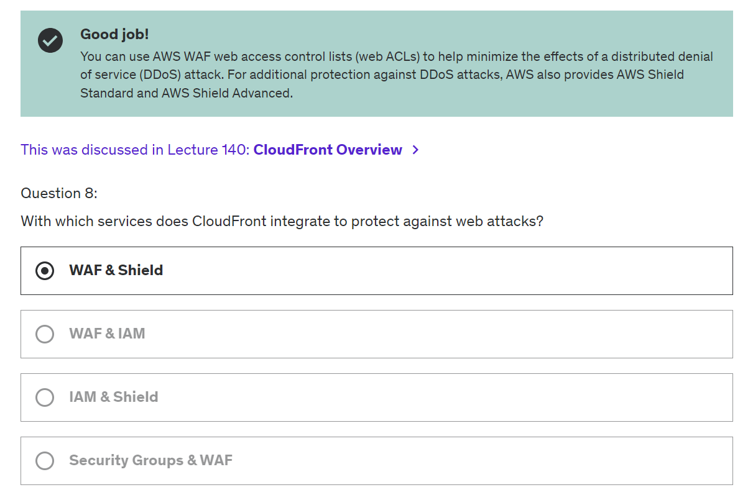

# Chapter 11: Cloud Integration

## 11.1 Simple Queue Service (SQS)

* Queue / Decouple

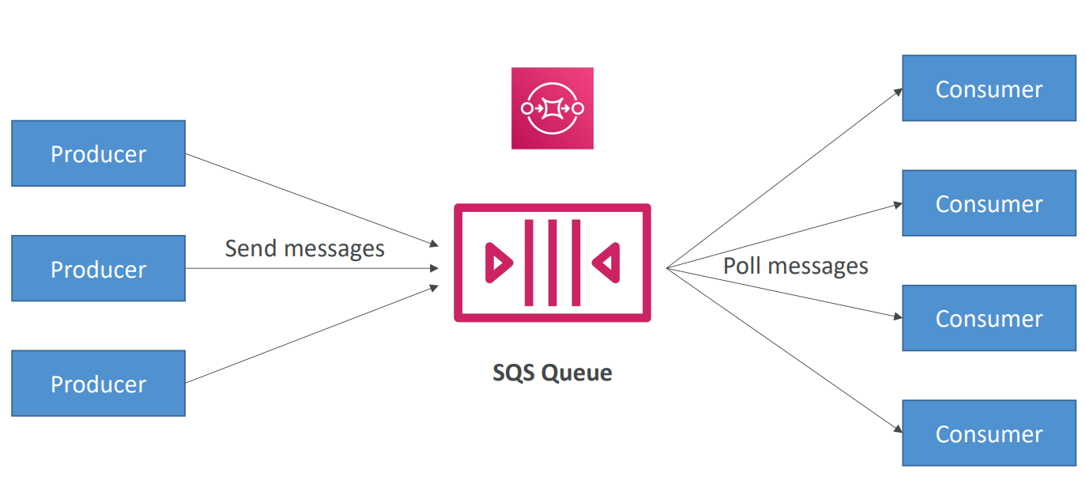

* Messages are deleted after they’re read by consumers
* Consumers share the work to read messages & scale horizontally

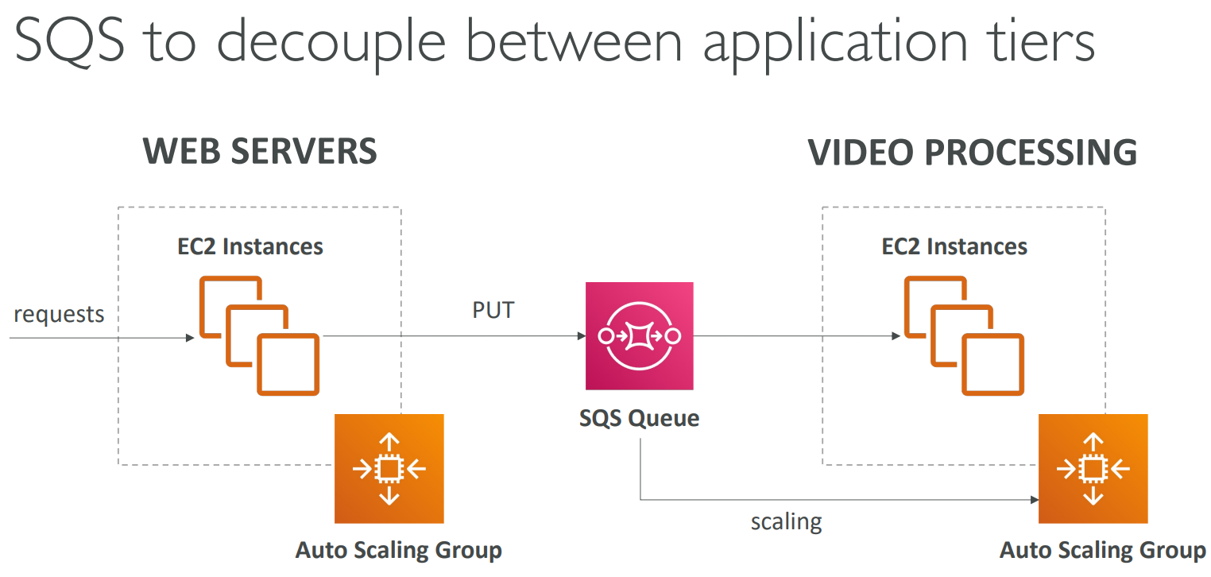

* Implement **FIFO** (ordering of messages in the queue)

## 11.2 Amazon Kinesis (Real time big data streaming)

* Manage service to collect, process and analyze real-time streaming data

## 11.3 Amazon Simple Notification Service (SNS)

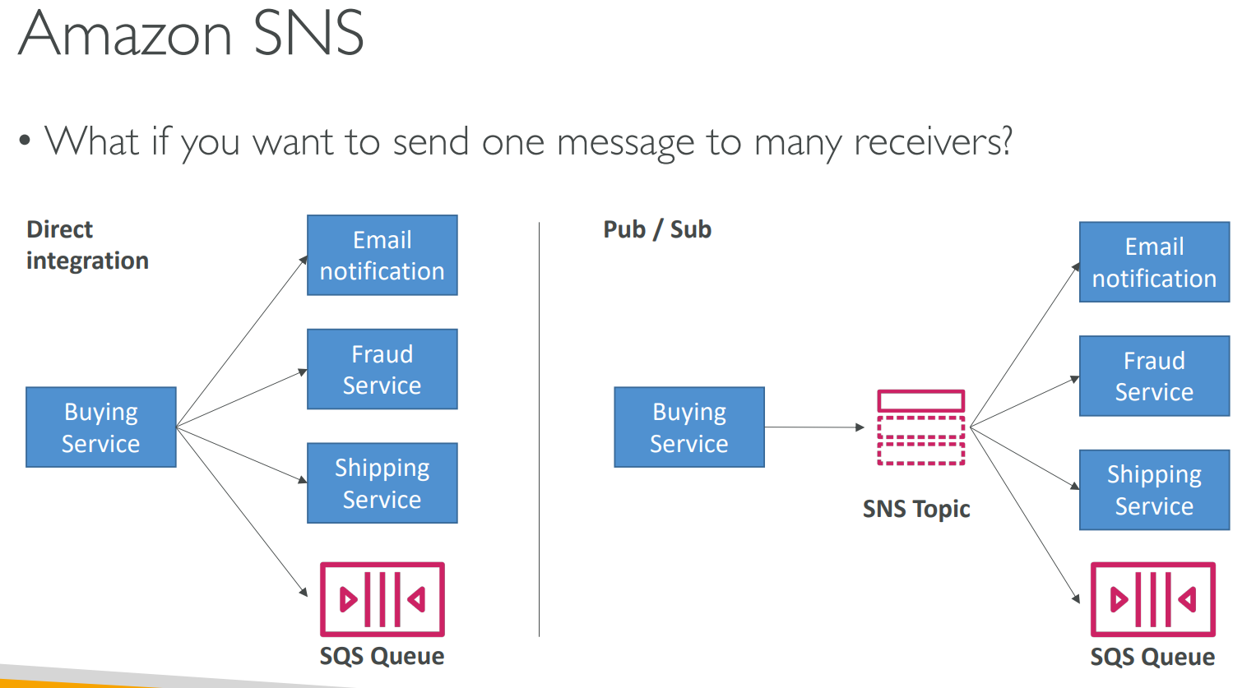

## 11.4 Amazon MQ

* Cloud-native MQ
* When migrate to cloud, we no need use SQS/ SNS
* Amazon MQ is managed message broker service for : **RabbitMQ / ActiveMQ**
* Doesn’t scale as much as SQS/ SNS

## 11.5 Hard Quiz

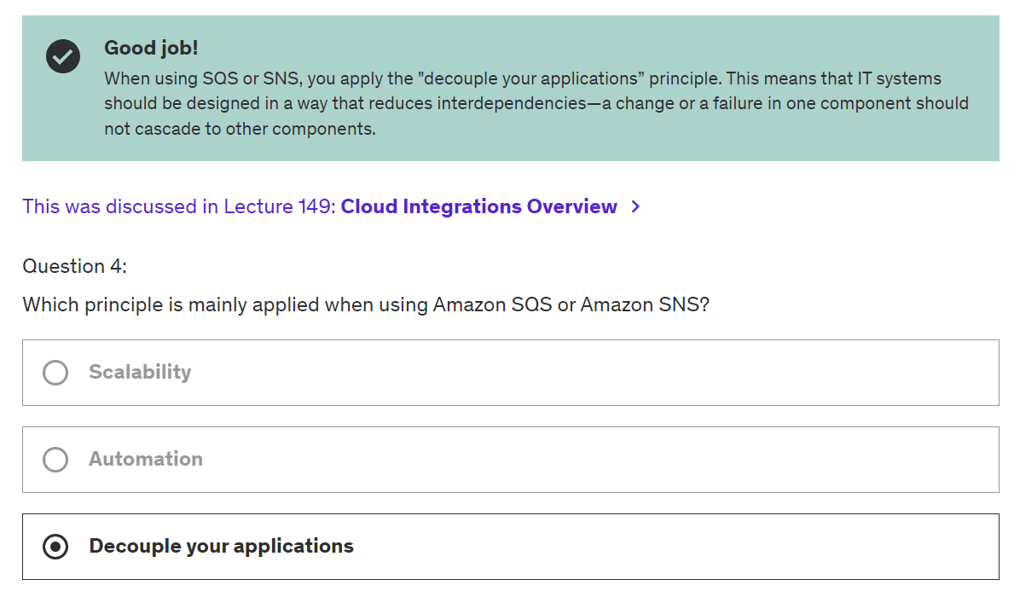

# Chapter 12: Cloud Monitoring

## 12.1 Amazon CloudWatch Metrics

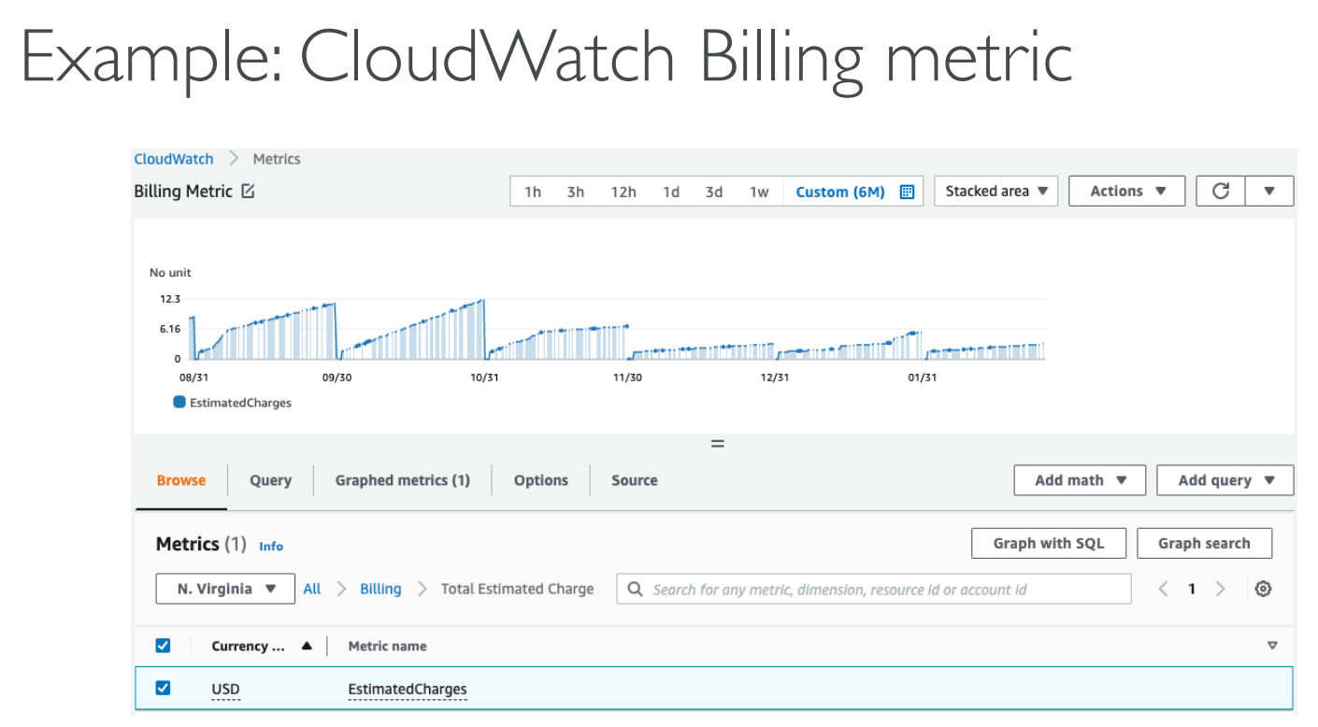

## 12.2 Amazon CloudWatch Alarms

* Alarms are used to trigger notifications for any metric
* Alarm States: OK. INSUFFICIENT_DATA, ALARM

## 12.3 Amazon CloudWatch Logs

* CloudWatch log agents: on EC2 machines or on-premises servers
* Enables real-time monitoring of logs

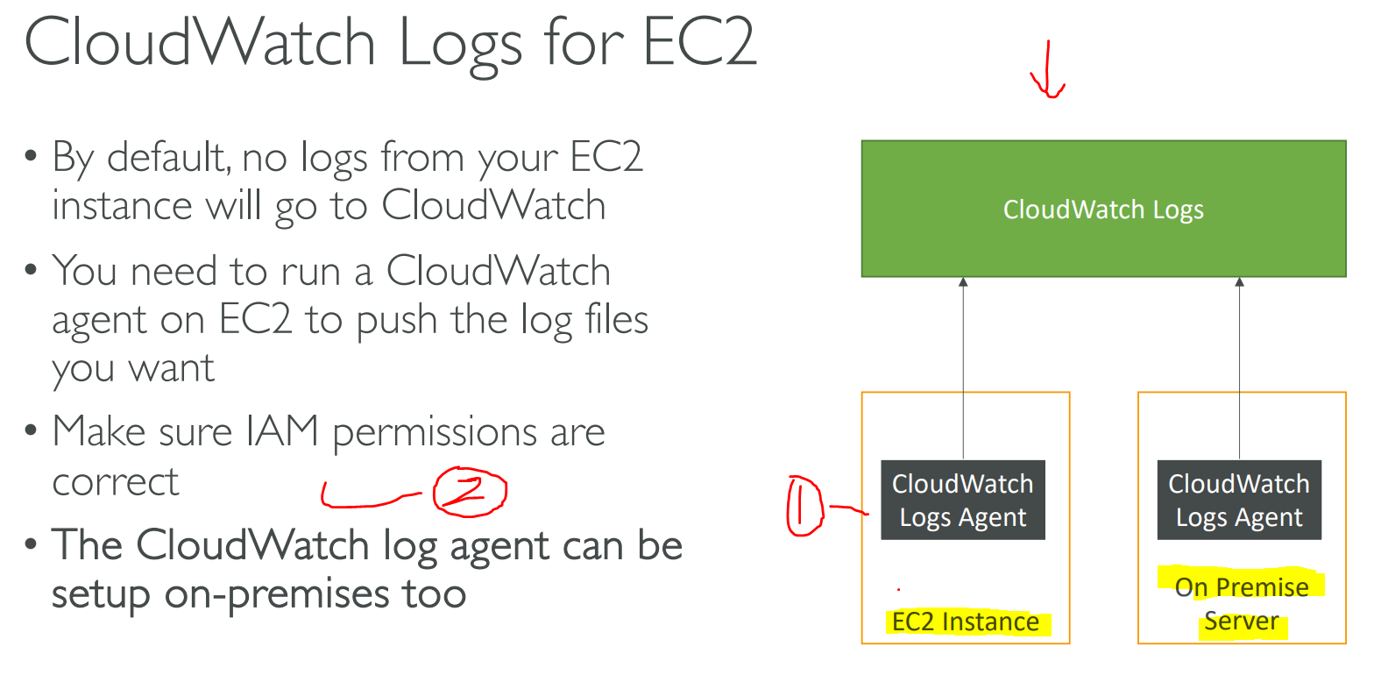

## 12.4 Amazon Event Bridge (Formerly CloudWatch Events)

* Schedule Cron jobs (scheduled scripts) – Every hour
* Event Pattern
* Trigger Lambda pattern. Send SMS

## 12.5 AWS CloudTrail (Audit API calls)

* Provides governance, compliance and audit for AWS acc
* A trail can be applied to All Region (default) or single Region
* If resource is deleted in AWS, investigate CloudTrail first

## 12.6 AWS X-Ray (Microservice)

* Common view for your architecture

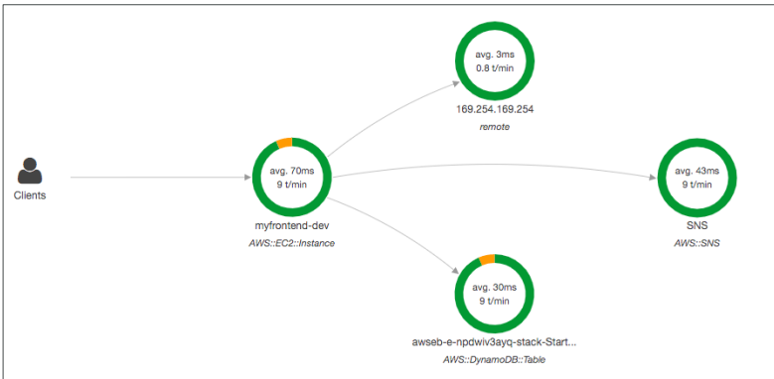

Advantages of X-Ray

* Troubleshoot performance
* Understand dependencies in microservice
* Find error and exceptions

## 13.7 Amazon CodeGuru

* ML-powered service for automated code review and recommendations

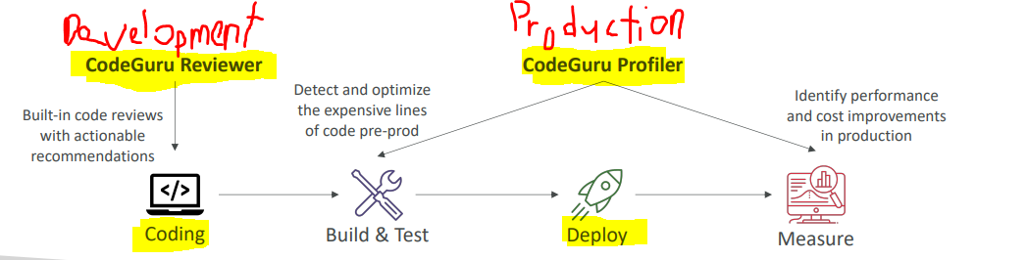

### 13.7.1 CodeGuru Reviewer

* Common coding best practices
* Security detection
* Input validation

### 13.7.2 CodeGuru Profiler

* Identify and remove code inefficiencies
* Improve app performance
* Decrease compute costs
* Anomaly Detection

## 13.8 AWS Health dashboard

### 13.8.1 Service History

* Show historical information for each day
* Has an RSS feed you can subscribe to

### 13.8.2 Your Account

* Provide alert and guidance when AWS found events that may impact you
* Give noti when got issues

# Chapter 14: Virtual Private Cloud (VPC) – like VPN

## 14.1 IP addresses in AWS

### 14.1.1 IPV4 (Public/ Private)

* Elastic IP (Fixed IPV4 to EC2)
* Charged $0.005 per hour

### 14.2.2 IPV6 (Public only)

* Free

## 14.2 VPC & Subnet Primer

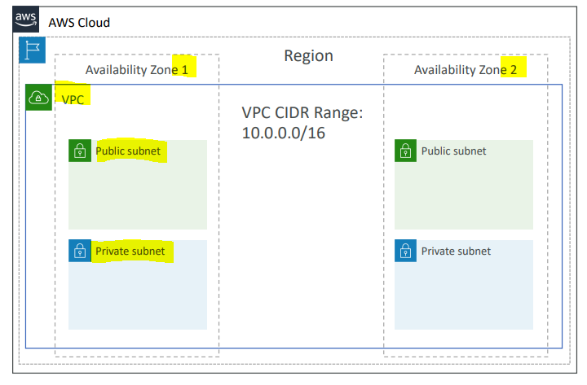

## 14.3 Internet Gateway (IGW) & NAT Gateway

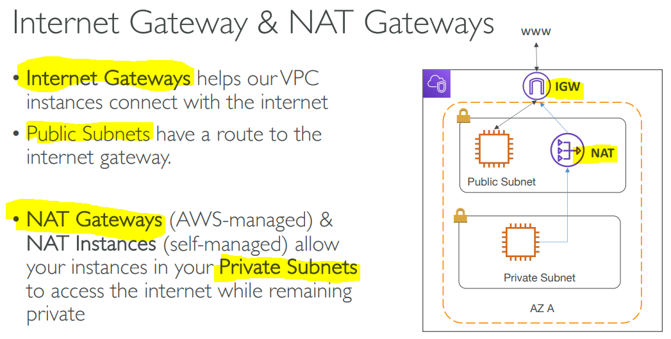

## 14.4 Network ACL & Security Group (Firewall)

### 14.4.1 Network ACL (NACL)

* Firewall (Subnet)
* Can have ALLOW & DENY rules
* Attached at Subnet level
* Rule only include IP addresses

### 14.4.2 Security Groups

* Stateless Firewall (ENI/ EC2 instance)
* Only ALLOW rules
* Rule include IP addresses and other security group

## 14.5 VPC Flow Logs

## 14.6 VPC Peering (P2P connection)

* Connect 2 VPC (privately using AWS network)

## 14.7 VPC Endpoints (S3)

* Allow you to connect to AWS Service using private network
* Enhanced Security + Low Latency

### 14.7.1 AWS PrivateLink

* Most secure + scalable way to expose a service to 1000 VPCs
* Does not require VPC peering, internet gateway, NAT, …

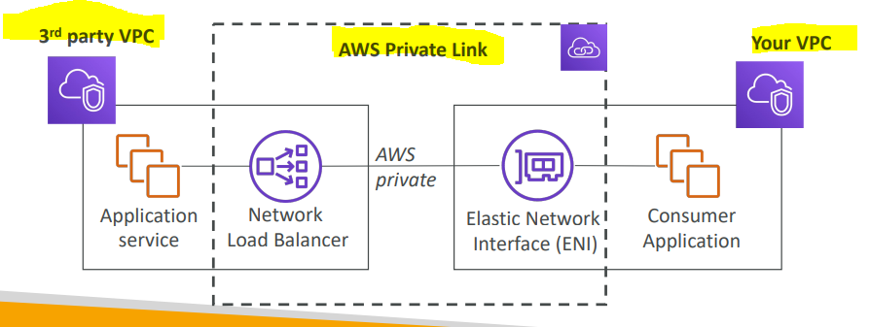

## 14.8 Site2Site VPN & Direct Connect

### 14.8.1 Site2Site VPN

* Connect on-premises VPN to AWS
* Goes over public internet (Less secure)
* Connection auto encrypted
* Cheap
* On Premise: Use Customer Gateway (CGW)
* AWS: Use Virtual Private Gateway (VGW)

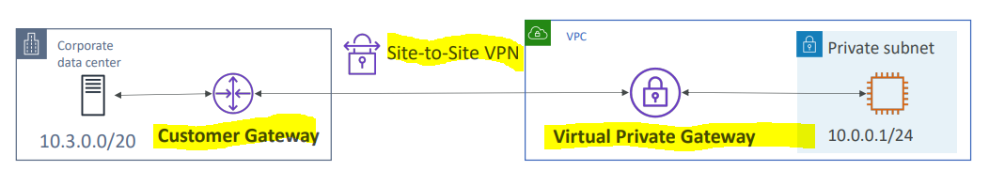

### 14.8.2 DirectConnect (DX) – Dedicated connect

* Expensive
* Establised physical/ dedicated connection between on-premises and AWS
* Connection is private, secure + fast

## 14.9 AWS Client VPN (OpenVPN – own laptop)

* Connect computer using OpenVPN
* Goes over public internet

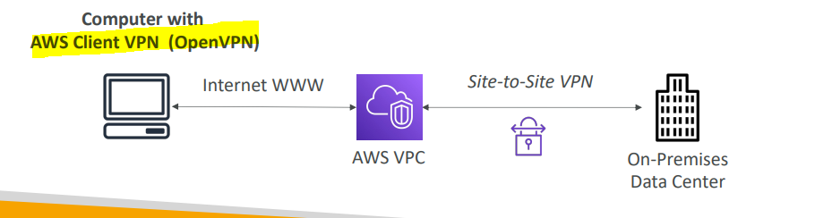

## 14.10 Transit Gateway (Connect thousands VPCs)

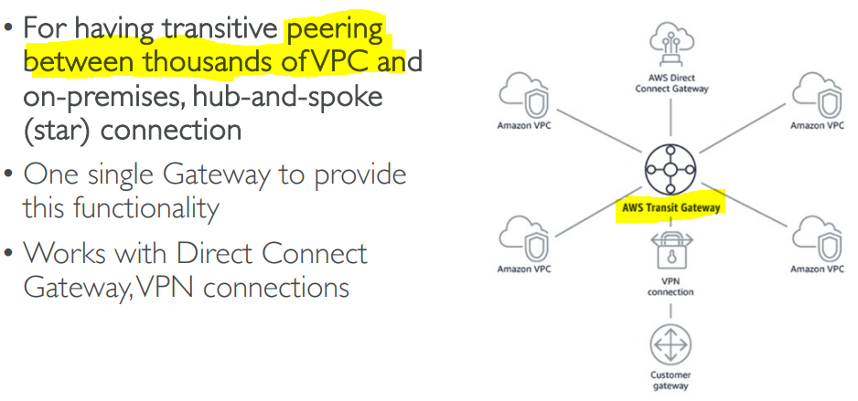

# Chapter 15: Security & Compliance

## 15.1 DDOS attack (DDOS = shield)

* AWS Sheild Standard : Free (Default for AWS customer)
* AWS Shield Advanced: 24/7 premium
* AWS WAF: Web App Filter (HTTP, SQL injection, XSS)
* CloudFront and Route 53: Availability protection using global edge network (attack mitigate at the edge)
* AWS Auto Scale

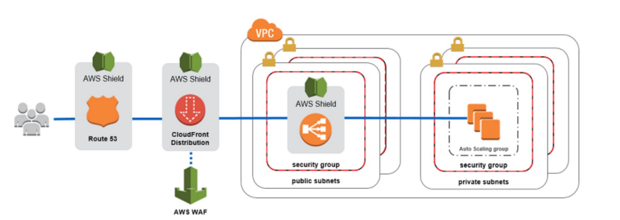

## 15.2 AWS Network Firewall (VPC threat)

* Protect entire Amazon VPC
* Layer 3 to 7 protection

### 15.2.1 AWS Firewall Manager

* Manage ALL security rules in ALL accounts of AWS Organization
* Rules that created will be applied to new (future) resources.

## 15.3 Penetration Testing (Self Attack test)

* Some services can be attack without prior approval.
* Cannot DNS zone walking via Route 53
* Cannot DDOS
* Port flooding
* Protocol flooding
* API request flooding

## 15.4 Encryption (KMS)

### 15.4.1 at rest

* Data stored or achieved on a device (hard disk, deep archieve, RDS)

### 15.4.2 in transit

* Transfer from on-premises to AWS.
* Means data transferred on network.

### 15.4.3 Key Management Service (KMS)

* Encryption s/w in AWS = “KMS”
* AWS manages the encryption key for us

### 15.4.4. CloudHSM

* AWS provision h/w encryption “CloudHSM”
* We manage the encryption key
* Expensive

### 15.4.5 Types of KMS Keys

* Customer Managed Key
* AWS Managed Key (anything start with “aws/” like “aws/s3”, “aws/ebs”
* AWS Owned Key (customer cannot view the keys)
* CloudHSM Keys (Key generated from CloudHSM h/w device)

## 15.5 AWS Certificate Manager (ACM) – HTTPS

* Let customer easily manage SSL/ TLS cert (HTTPS)
* FOC for TLS cert

## 15.6 AWS Secret Manager

* Capability to force rotation of secrets. (Monthly/ a period of time)
* Integration with Amazon RDS (MySQL, Postgres)

## 15.7 AWS Artifact

Portal provides customer with on-demand access to AWS compliances docs and agreements

* **Artifact Reports –** Download AWS Security and compliance docs from 3rd party auditors like AWS ISO cert, Payment Card Industry (PCI)
* **Artifact Agreements –** Review, Accept and track status of AWS agreements such as Business Associate Addendum (BAA) or Health Insurance Protability and Accountability Act (HIPAA)

## 15.8 Amazon GuardDuty (Antivirus)

* Intelligent Threat discovery
* One click enables (30 days trail)
* Can protect against Cryptocurrency attacks.

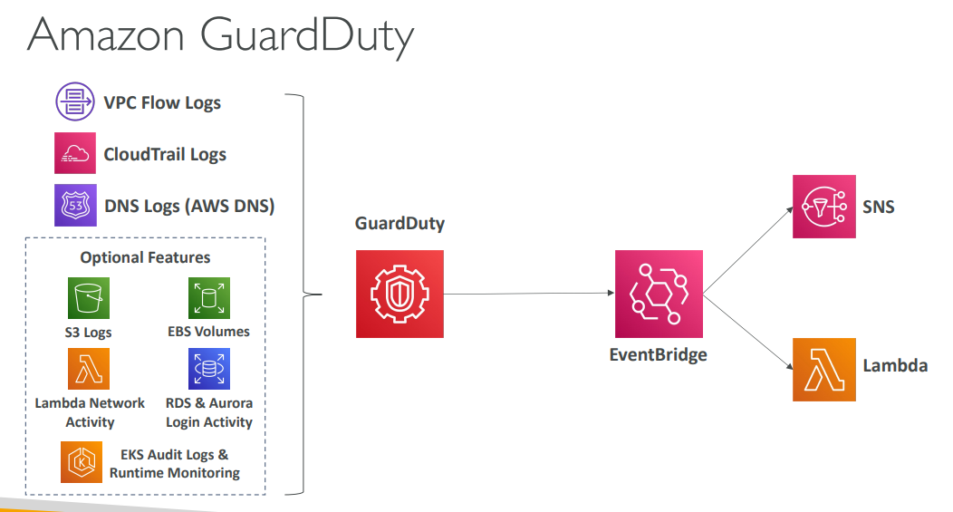

## 15.9 Amazon Inspector

* Automated Security Assessments
* Inspect EC2 instances, Container Images push to Amazon ECR, Lambda Functions
* Package Vulnerability (EC2, ECR, Lambda)
* Network Vulnerability (EC2 only)
* Report and integrate with AWS Security Hub
* Send findings to Amazon Event Bridge
* Risk Score will be produced at the end

## 15.10 AWS Config

* Record config and changes over time (Compliant to rules? / how many changes? / who did the change?)
* AWS Config is per-region service (can be change to across regions and accounts)

## 15.11 Amazon Macie

* Identify and alert you to sensitive data, such as personally identifiable information (PII)

## 15.12 AWS Security Hub

* Central Security tool to manage security across several AWS accounts and automate security checks.
* Integrated dashboard
* Must enabled AWS config service

## 15.13 Amazon Detective

* Analyze, investigate, and quickly identify the root cause of security issues (using ML and graphs)

## 15.14 AWS Abuse

* Report suspected AWS resources used for abusive/ illegal purpose.
* Like port scan, spam, DDOS, intrusion attempts, malware.

## 15.15 Root user privileges

* Root user = Account Owner
* Lock AWS root user access key!

### 15.15.1 Action that can be done by the root user

* Change account settings
* Close your AWS account
* Change or cancel your AWS Support plan
* Register as a seller in the Reserved Instance Marketplace

## 15.16 IAM Access Analyzer

* Define Zone of Trust = AWS Acc or Organization
* Access outside zone of trust => findings

## 15.17 Hard Quiz

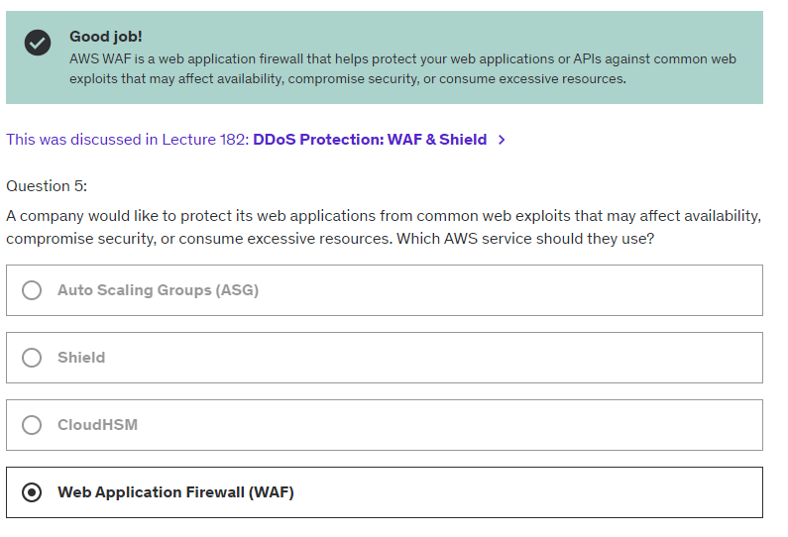

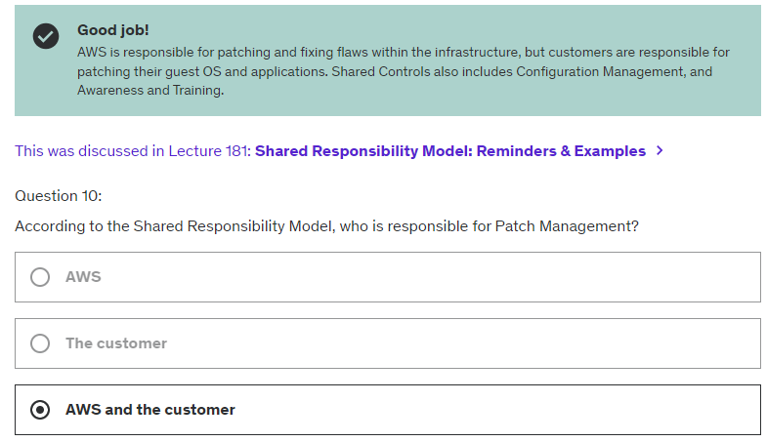

# Chapter 16: ML

## 16.1 Amazon Rekognition

* Image and video recognition

## 16.2 Amazon Transcribe (speech to text)

* Use deep learning process called automatic speed recognition (ASR)

## 16.3 Amazon Polly (text to speech)

## 16.4 Amazon Translate

## 16.5 Amazon Lex & Connect

### 16.5.1 Lex (Same tech that power Alexa)

* Can ASR (Amazon Transcribe)
* Helps build chatbots, call center bots

### 16.5.2 Connect

* Receive calls, create contact flows, cloud based virtual contact center
* Can integrate with other CRM

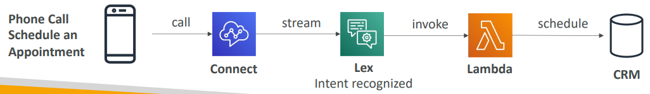

## 16.6 Amazon Comprehend (NLP)

* Natural Language Processing (NLP)
* Find insights and relationships in text

## 16.7 Amazon SageMaker

* Fully managed service for developers/ data scientists to build ML models

## 16.8 Amazon Forecast

## 16.9 Amazon Kendra (Similar to ChatGPT)

* Document search service powered by ML
* Extract answer from within a docs (text, pdf, KTML, ppt)
* Learn from user interactions/ feedback (Incremental learning)

## 16.10 Amazon Personalize

* ML realtime personalized recommendations
* Same tech used by Amazon

## 16.11 Amazon Textract

* Extract text, handwriting and data from scanned docs.

# Chapter 17: Acc managements, billing & support section

## 17.1 AWS Organizations

* Allows to manage multiple AWS accounts
* Consolidated Biling (1 Master acc pay all child acc)
* Pricing benefit from aggregated usage
* Pooling of Reserved EC2 instances
* Automate AWS account creation.
* Restrict account privileges using Service Control Policies (SCP)

### 17.1.1 Service Control Policy (SCP) – Multi Account Strategy

* Whitelist/ Blacklist IAM actions
* Applied at Organization Unit (OU) or Account level
* Does not apply to Master Account
* SCP is applied to all the Users and Roles

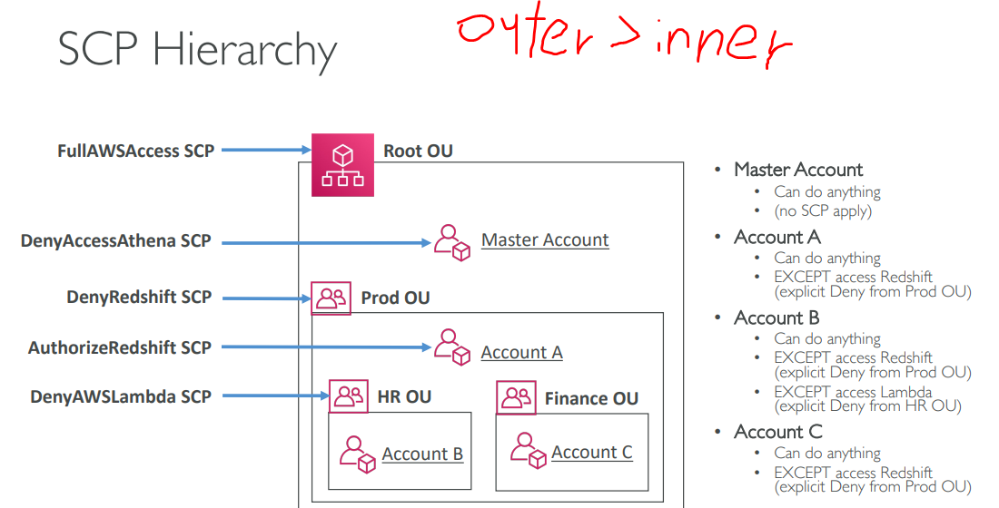



### 17.1.2 Consolidated Biling

* Share volume Pricing (Reserved Instance/ Saving Plan discount)

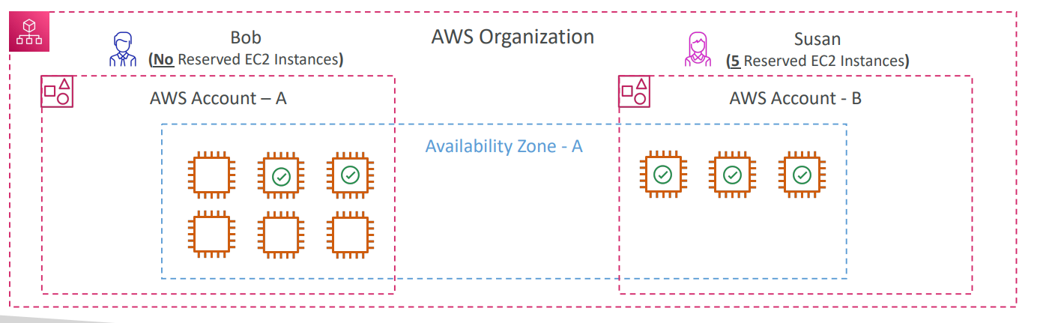

## 17.2 AWS Control Tower (Complaint Multi Acc)

* Set up secure and compliant multi acc AWS environment.
* Automate set up environment.
* Auto ongoing policy management using guardrails
* Detect policy violations and remediate them
* Monitor compliance through dashboard

## 17.3 AWS Resource Access Manager (AWS RAM)

* Share resource to other acc

## 17.4 AWS Service Catalog (Portal of product catalog)

* Quick Service Portal -> launch authorized products allow by admins

## 17.5 Pricing Models in AWS

* Pay as you go
* Save when you reserve
* Pay less by using more
* Pay less as AWS grows

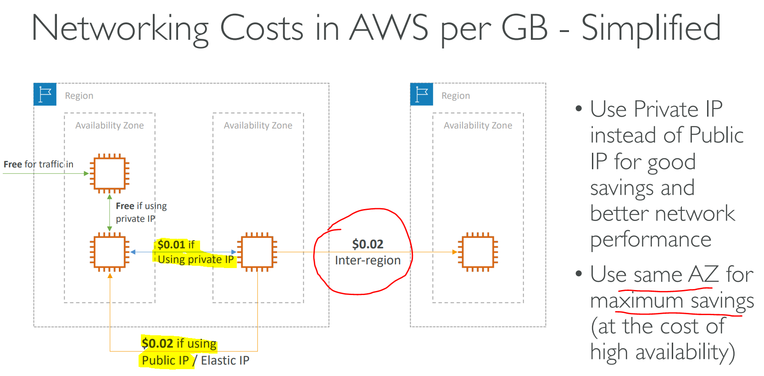

## 17.6 AWS Compute Saving Plan (Support Lambda)

* Commit fix $ amount per hour (in 1/3 year)
* Eg: EC2 Saving Plan (All upfront, partial upfront, no upfront)

## 17.7 AWS Compute Optimizer (ML for resource)

* Reduce costs and improve performance.
* Use ML to analyze resource config (by assist of CloudWatch metric dashboard)

## 17.8 Biling and Costing Tools

* Pricing calculator (estimate)
* Biling dashboard (tracking)
* Biling alarm (monitoring)

## 17.9 Cost Explorer (Forecast Usage)

* Forecast Usage up to 12 months based on previous usage

## 17.10 AWS Cost Anomaly Detection

* ML -> Identify unusual Spend -> alert -> find root cause

## 17.11 AWS Service Quotas

* Notify when close to service quota value threshold.
* Eg: Lambda concurrent executions
* Can request quota increase/ shutdown the resource.

## 17.12 Trusted Advisor

Recommend:

* Cost optimization
* Performance
* Security
* Fault tolerance
* Service limits.
* Operational Excellence

## 17.13 Support Plan

### 17.13.1 Basic Plan (Free)

### 17.13.2 Developer Support Plan

* Business hour email access to Cloud Support
* 1 primary contact

### 17.13.3 Business Support Plan

* Full set of check (trusted Advisor)
* 24x7 phone, email and chat access to Cloud Support
* Unlimited contact

### 17.13.4 Enterprise On-Ramp

* Access to pool of designated Technical Account Manager (TAM)
* Concierge Support Team
* Infrastructure Event Management, Well-Architected & Operations Reviews

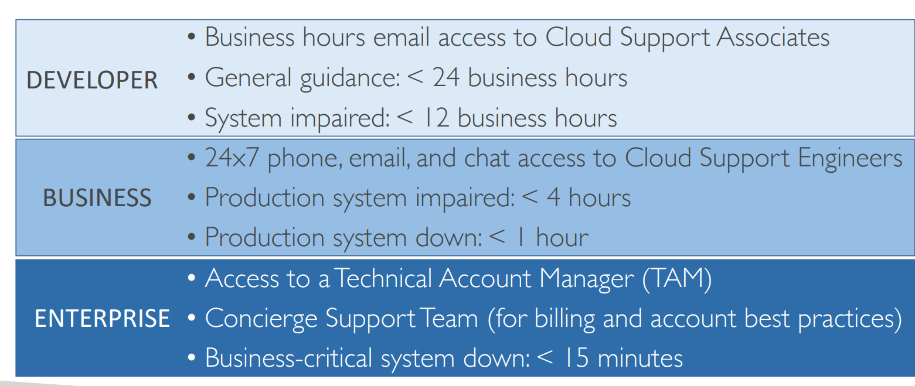

## 17.14 Hard Quiz

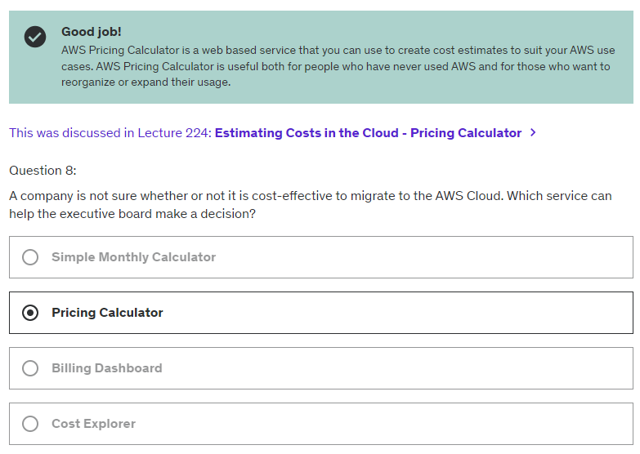

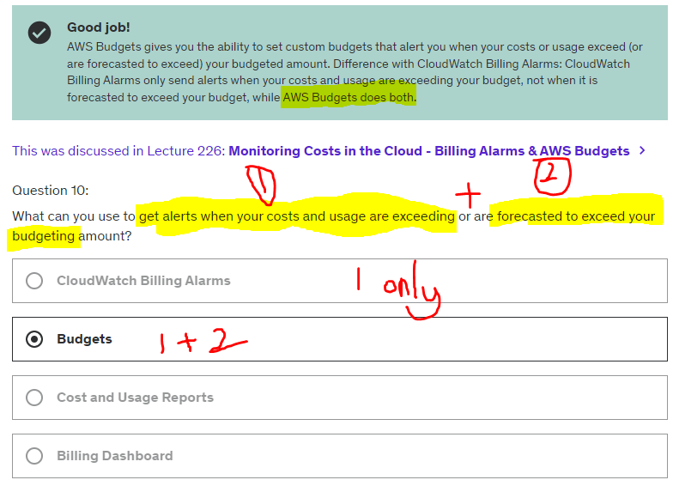

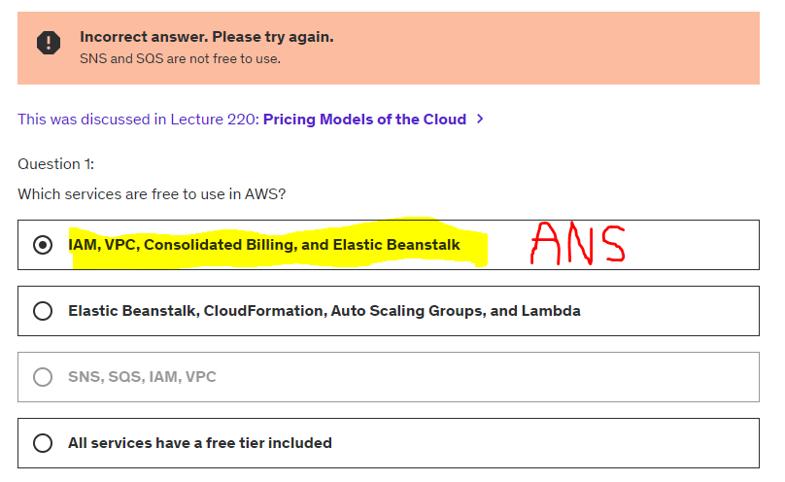

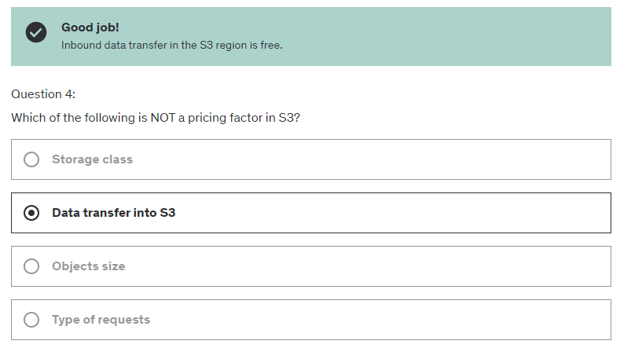

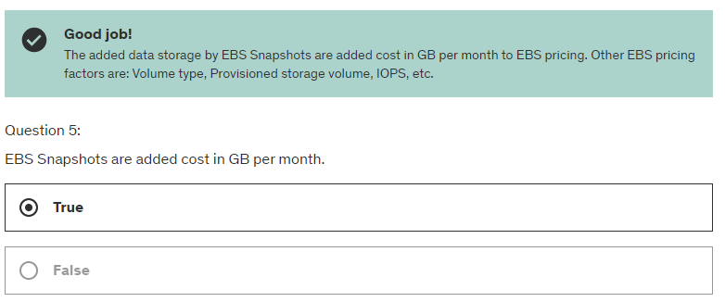

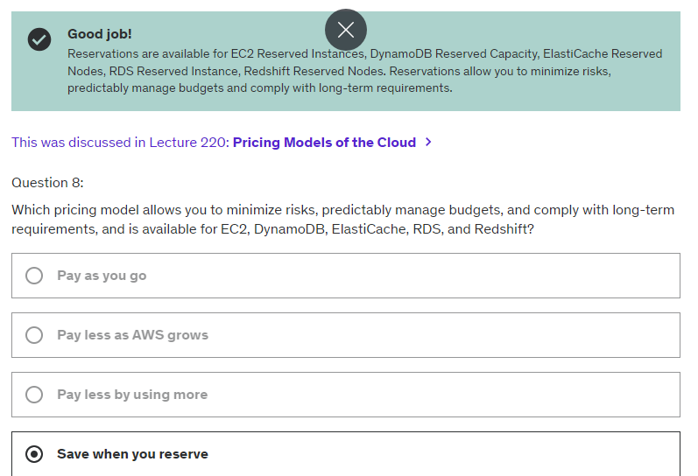

# Chapter 18: Advanced Identity

## 18.1 AWS STS (security Token Service) – similar JWT (Oauth)

* Able to create temp, limited credentials.
* Short term credentials

## 18.2 Amazon Cognito (User)

* Identity for web/ mobile app user
* Should not use IAM, use Cognito

## 18.3 Microsoft Active Directory (AD)

* Database of object (User account, Computer, Printer, Security Group)

## 18.4 AWS Directory Service

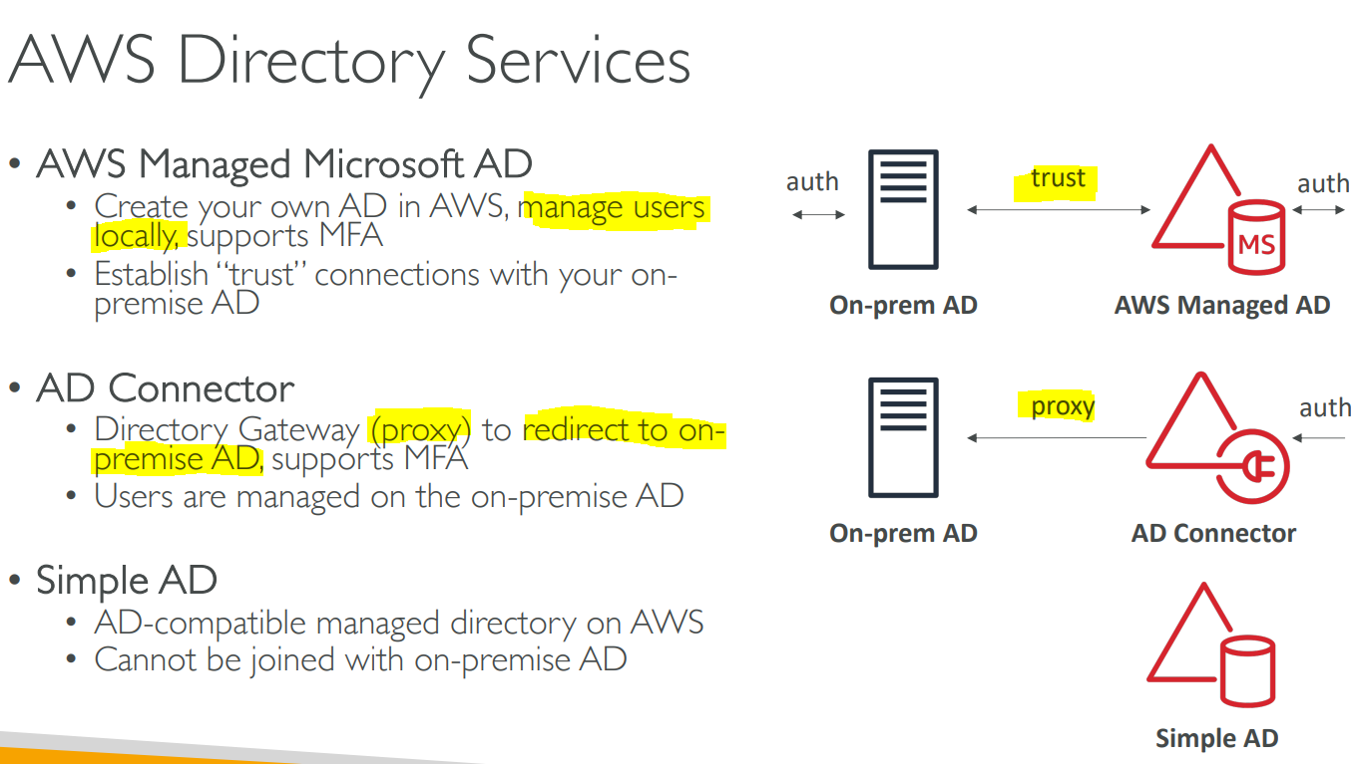

## 18.5 AWS IAM Identity Center (SSO)

SSO to :

* AWS acc in AWS organization
* Business cloud app
* SAML 2.0 enabled app
* EC2 Windows Instances

# Chapter 19: Other AWS Services

## 19.1 Amazon WorkSpaces (Liked VM)

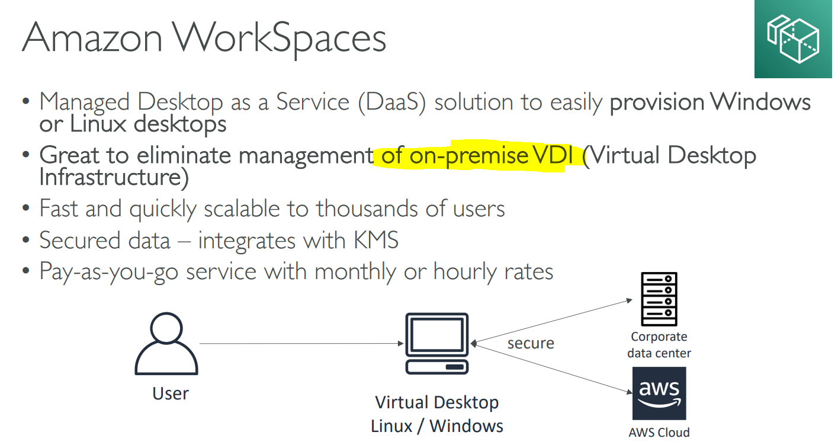

## 19.2 Amazon AppStream 2.0

Can RUN APP on BROWSER like

* Blender
* Eclipse
* Firefox
* CAD

## 19.3 AWS IoT Core

* Easily connect IOT de to AWS Cloud
* App can still communicate with the IOT device even disconnect

## 19.4 AWS AppSync (GraphQL)

* Sync data across mobile and web apps
* Makes use of GraphQL (mobile technology from Facebook)

## 19.5 AWS Amplify

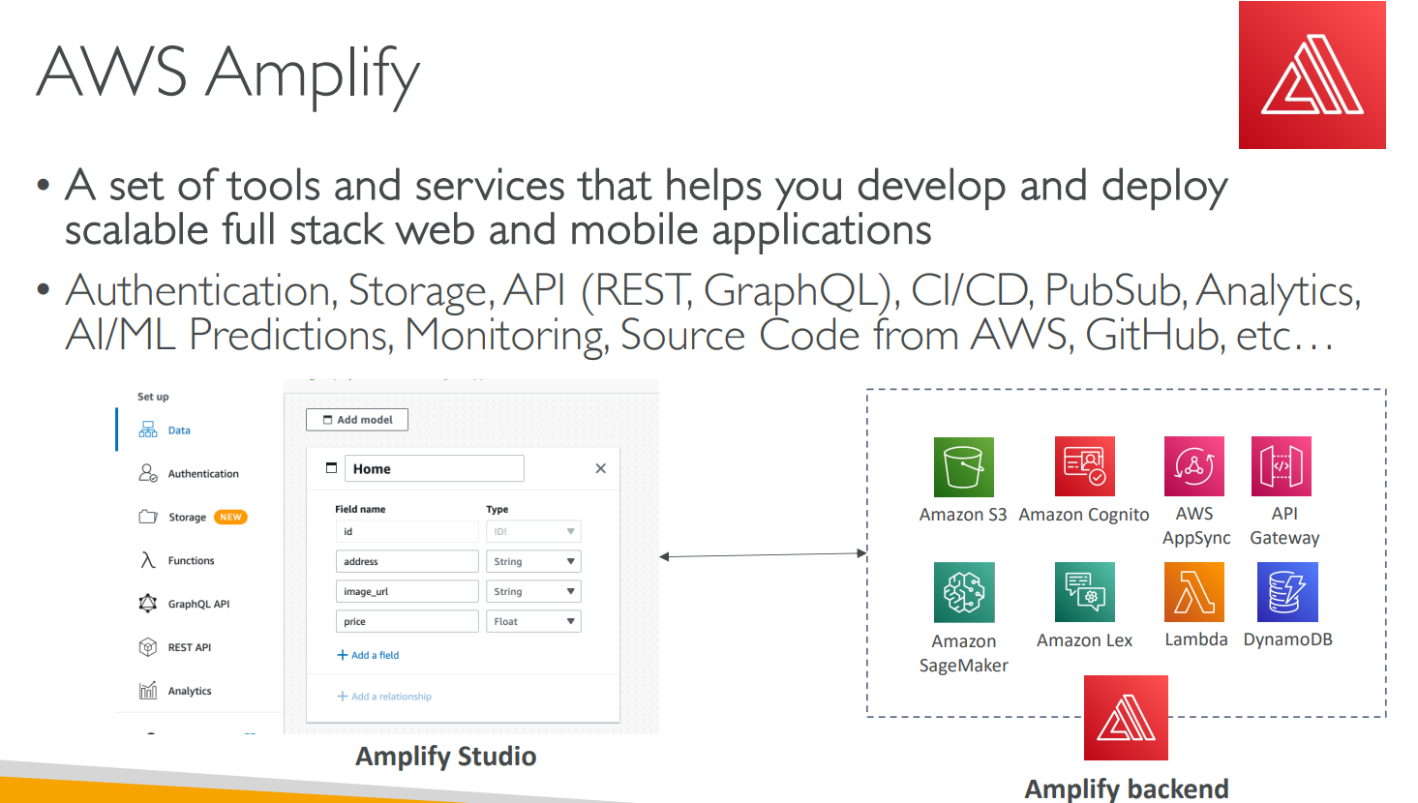

## 19.6 AWS Application Composer

* Visually design and build serverless applications quickly on AWS
* Deploy AWS infrastructure code without needing to be an expert in AWS
* Generates Infrastructure as Code (IaaC) using CloudFormation

## 19.7 AWS Device Farm

* Test App on AWS
* Real Device (Not emulator)

## 19.8 AWS Backup

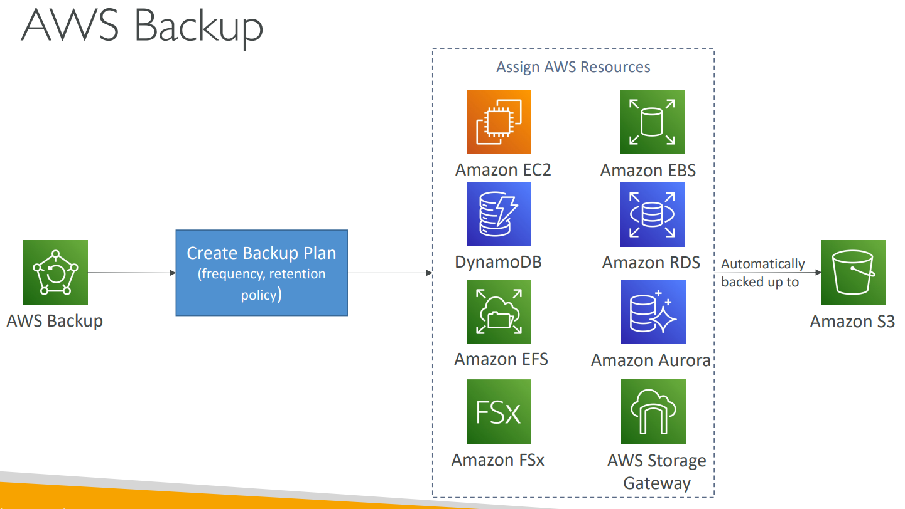

## 19.9 Disaster Recovery Strategies

### 19.9.1 Backup and Restore (#1 Cheapest)

* No Backup App
* Only to S3 Bucket

### 19.9.2 Pilot Light (#2 Cheap)

* Backup Core functions of the app

### 19.9.3 Warm Standby (#3 Expensive)

* Backup full version of the app, but at minimum size

### 19.9.4 Multi-Site / Hot-Site (#4 Most expensive)

* full version of the app, at full size

## 19.10 AWS Elastic Disaster Recovery (DRS)

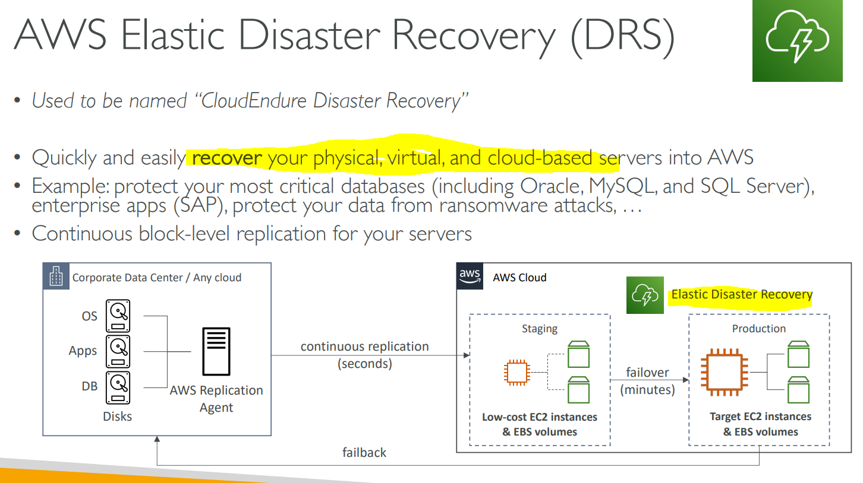

## 19.11 AWS DataSync (Incremental)

* Move large amount of data from on-premises to AWS
* The replication tasks are incremental after the first full load

## 19.12 Cloud Migration Strategy (7R)

1. Retire

* Turn off things that don’t need
* Save cost and more secure (turn off surface area)

1. Retain

* Do nothing for now (Decision to move to cloud)

1. Relocate

* Move apps from on-premise to Cloud
* Move EC2 Instances to different VPC

1. Rehost “lift and shift”

* Simple migrations by re-hosting on AWS
* Migrate machines.

1. Replatform “lift and shape”

* Migrate database to RDS
* Migrate app to Elastic Beanstalk

1. Repurchase “drop and shop”

* Moving different product while moving to Cloud
* Expensive in short term but Quick to deploy

1. Refractor / Re-architect

* Move monolithic app to microservices

## AWS Application Discovery Service

* Plan migration by gather information about on-premises data center

Got 2 types:

* Agentless Discovery (AWS Agentless Discovery Connector) – CPU, memory
* Agent-based Discovery (AWS Application Discovery Agent) – config, running processes

## AWS Application Migration Service (MGN) DB -> EC2

* Migrating applications to AWS

## AWS Migration Evaluator

## AWS Migration Hub

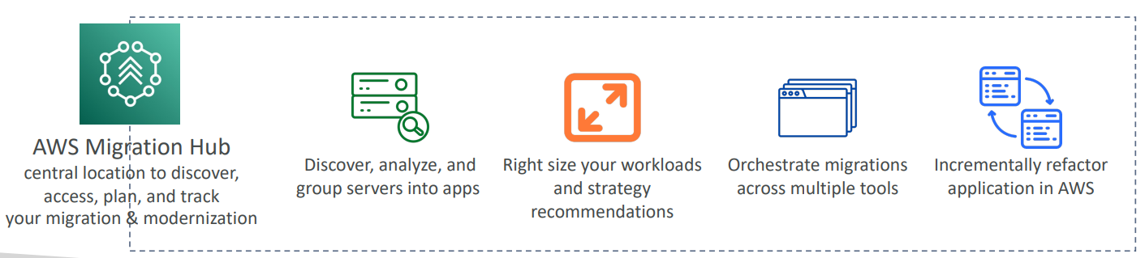

## AWS Fault Injection Simulator (FIS) – Chaos Engineering

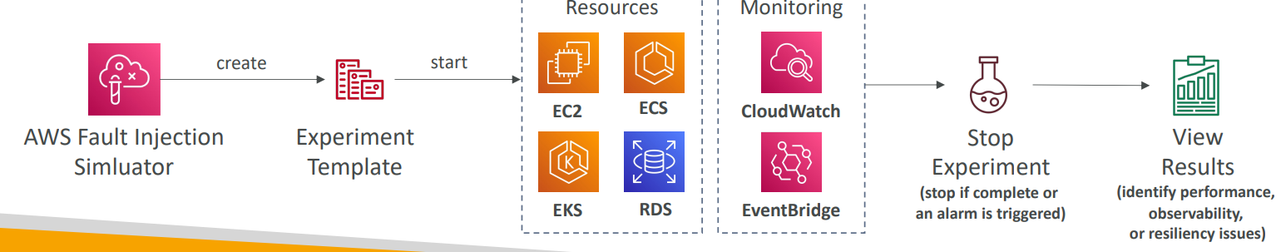

## AWS Step Functions (FlowChart)

* Virtual workflow to orchestrate your Lambda functions

## AWS Ground Station (Satelite)

Use cases:

* Surface Imaging
* Communication
* Video broadcast

## Amazon Pinpoint

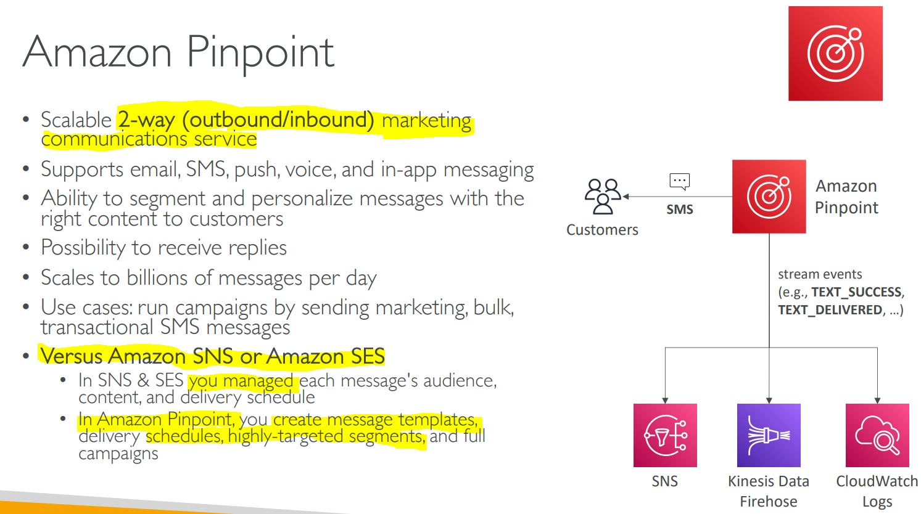

# Chapter 20: AWS Architecting & Ecosystem

## 20.1 AWS Cloud Best Practices – Design Principles

* Scalability
* Disposable Resources
* Automation
* Loose Coupling
* Services, not Servers

## 20.2 Well Architected Framework

### 20.2.1 Operational Excellence

* Run and monitor systems to deliver business value and to continually improve supporting processes and procedures.

Design Principles

* Perform operations a code
* Testing and Refine

### 20.2.2 Security

Design Principles

* IAM
* Detective Control
* Infrastructure Protection
* Data Protection
* Incident Response

### 20.2.3 Reliability

Design Principles

* Testing recovery procedures
* Stopping guessing capacity
* Managing changes

AWS Service: **CloudWatch**, **CloudTrail, Config**

### 20.2.4 Performance Efficiency

Design Principles

* Democratize advanced technologies
* Go global in minutes
* Use serverless architectures
* Experiment more often

### 20.2.5 Cost Optimization

Design Principles

* Expenditure Awareness
* Cost-Effective Resources
* Matching supply and demand
* Optimizing Over Time

### 20.2.6 Sustainability

Minimizing the environmental impacts of running cloud workloads

Design Principles

* Understand your impact
* Set long-term goals on ROI
* Maximize utilization
* Adopt latest technology
* Use Managed service
* Reduce downstream impact (human resource) impact to your workload

## 20.3 AWS Well-Architected Tool

Free tool to review your architectures against the 6 pillars Well-Architected Framework and adopt architectural best practice. (By applying lenses)

## 20.4 AWS Cloud Adoption Framework (AWS CAF)

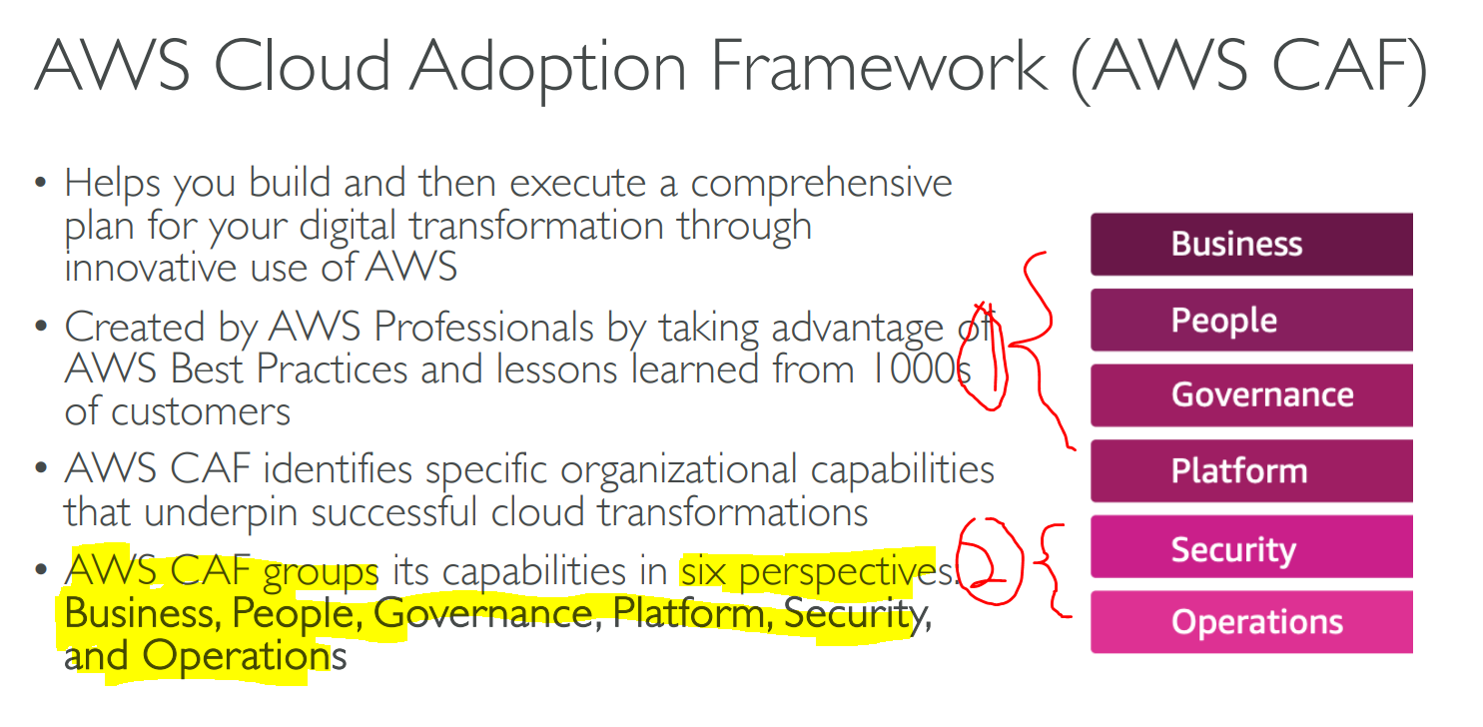

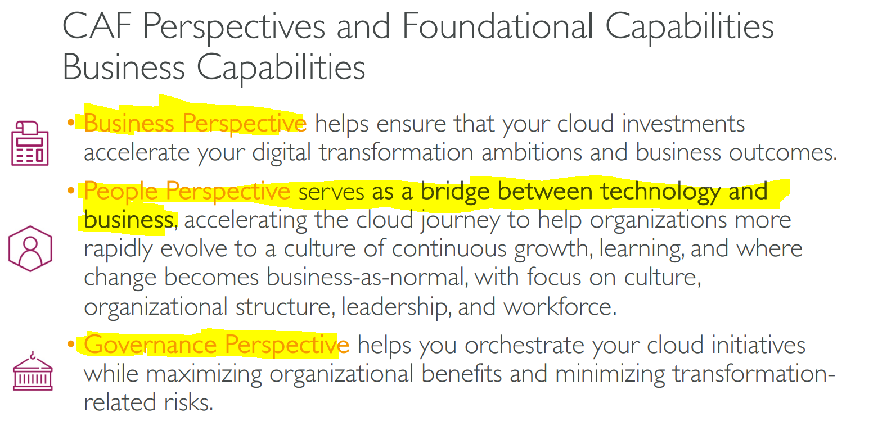

Platform – Build enterprise, modern app. Stakeholder: Tech Lead, architect, engineer

Security – Stakeholder: security staff, internal audit

Operations – Helps ensure cloud service meets business needs. Stakeholder: IT staff, site reliable engineer

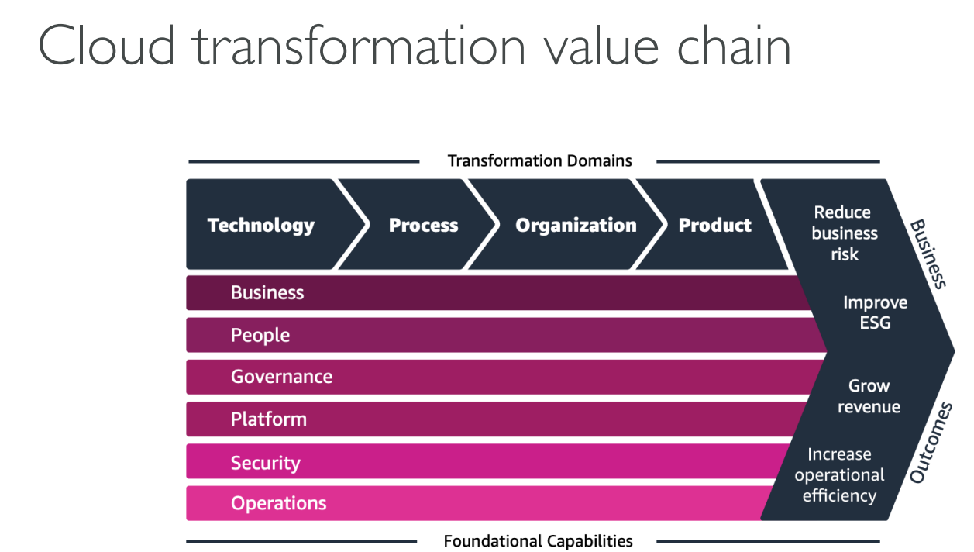

### 20.4.1 AWS CAF –Transformation Domains

* Technology – use cloud to migrate legacy app
* Process – digitizing, automating, optimizing business processes (ML)
* Organization – Organizing back the operating model
* Product – Creating new value propositions and revenue model

### 20.4.2 AWS CAF –Transformation Phases

* Envision - demonstrate how the Cloud will accelerate business outcomes by identifying transformation opportunities
* Align – identify capability gaps across the 6 AWS CAF Perspectives
* Launch – build and deliver pilot initiatives in production
* Scale – expand pilot initiatives to the desired scale

## 20.5 AWS Right Sizing

* Most powerful != Most suitable (because cloud is elastic)
* Right Sizing = Best matching option + cheapest
* Scaling up is easy -> always start small

## 20.6 AWS IQ (Professional Freelancer Support)

* Find Professional to assist (can pick the one you desire)

## 20.7 AWS re:Post (forum)

## 20.8 AWS re:Post – Knowledge Center (Most common ask FAQ)

## 20.9 AWS Managed Services (AMS) – AWS Team experts

* AMS offers a team of AWS experts who manage and operate your infrastructure for security, reliability, and availability.

## 20.10 Hard Quiz

